29.01.21

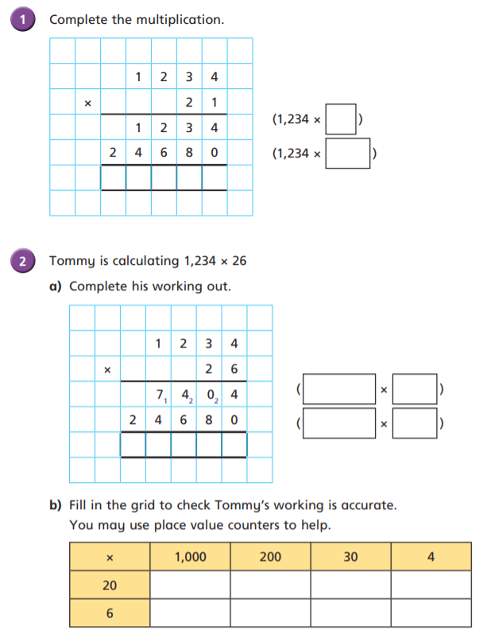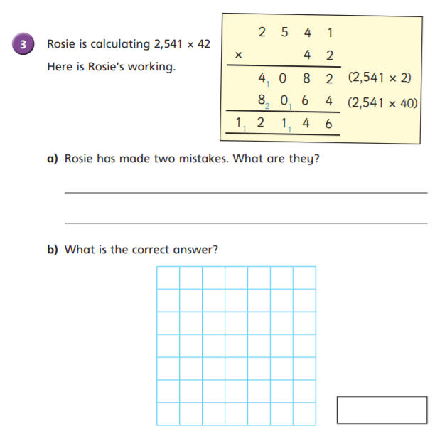LO: I can multiply a four-digit number by a 2-digit number.

1

20

2 5 9 1 4

She forgot to place 0 to show the product of a multiple of 10 (40) so she only multiplied 2541 by 4.

She forgot to add her exchanged thousand on the (2541 x 2) row.

1234

1234

20

6

3 2 0 8 4

106,722

80

600

4,000

20,000

24

180

1,200

6,000

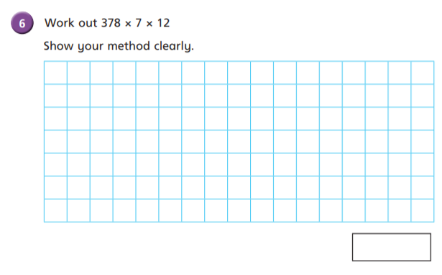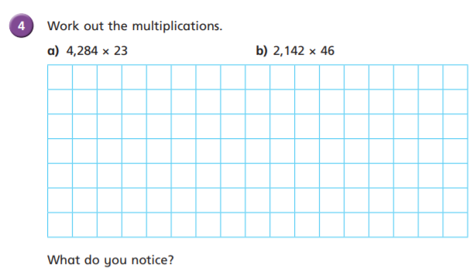

2 1 4 2

4 2 8 4

8 5 6 8 0

9 8 5 3 2

7 x 1 2 = 8 4

4

4 6 x

1 2 8 5 2

8 5 6 8 0

9 8 5 3 2

1 2 8 5 2

2 3 x

1 5 1 2

3 0 2 4 0

3 7 8

8 4 x

3 1 7 5 2

When you halve one factor and double the other factor, the product stays the same.

31,752

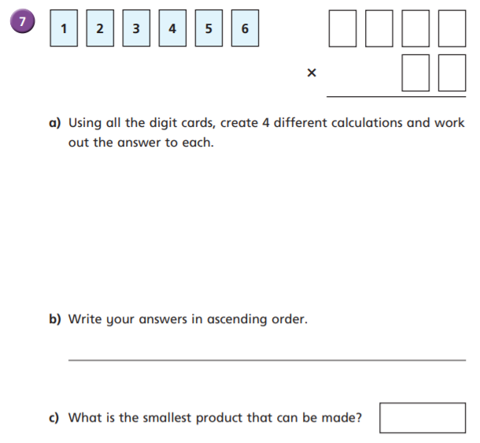

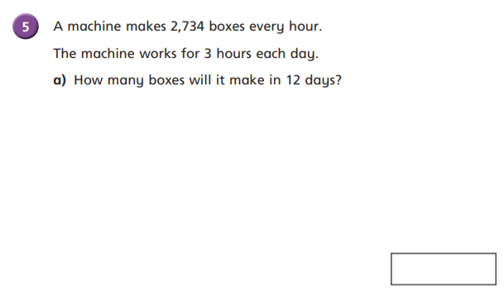

You could have created lots of different calculations! Check your answers with a calculator.

98,424

Remember, this means ‘getting larger’, so from smallest to largest

31,928

2456 x 13 = 31,928

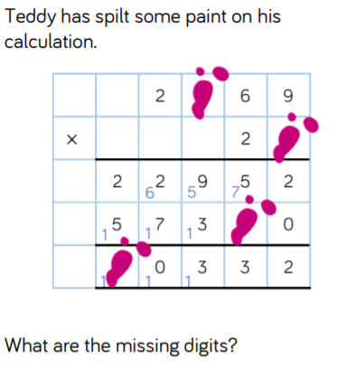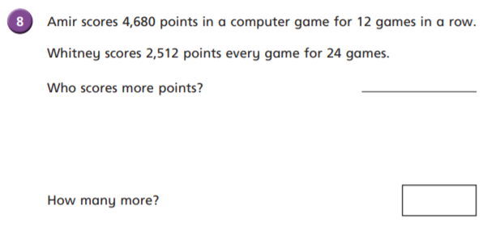

Whitney

4680points x 12games = 56,160 points

2512points x 24games = 60,288 points

4,128 points

All of the missing digits are 8! I think the simplest way to approach this was to work through it as if you were calculating, starting with the ones. You can see that your total was 72 ones. So you know that ‘some ones x 9 = 72’ ***8*** x 9 = 72

Then move through the calculation, working out missing boxes as you go. The next missing box you would come to is 8 (now that you know the second factor is 28) x an amount of hundreds = 64 hundreds (remember you wouldn’t have added on your 5 exchanged hundreds from your tens column yet). You know that 8 x 8 = 64, so 8 x 8hundreds = 64 hundreds.

Next, you would come across the missing box representing ’20 x 9 =’ Hopefully you calculated the answer as 180. 0 in the ones, 8 tens and 1 hundred exchanged.

Finally, you needed to add together the ‘thousands’ from the parts of the product to find the total product. 2 thousands, plus 5 thousands, plus your exchanged thousand from the hundreds = 8 thousands.

Well done if you worked this all out 😊