22.01.21

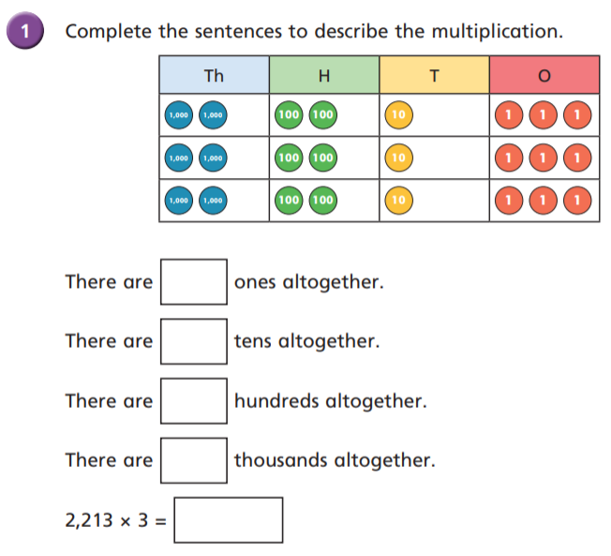LO: I can multiply four-digit numbers by a one-digit number.

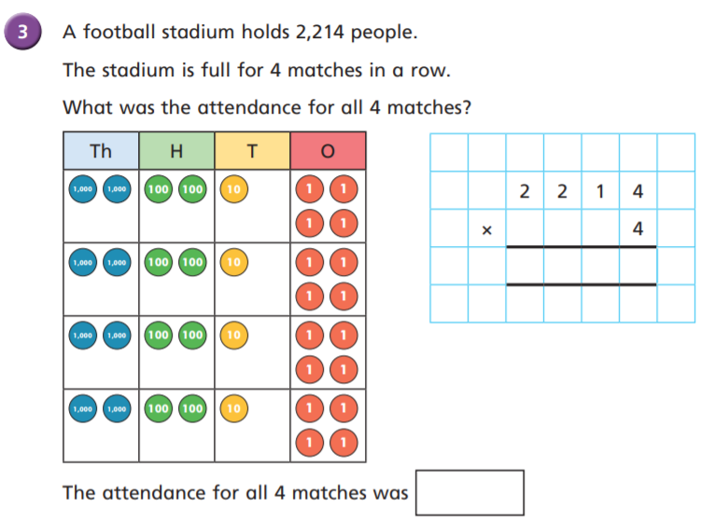

1

8 8 5 6

9

3

8 8 5 6

6

6

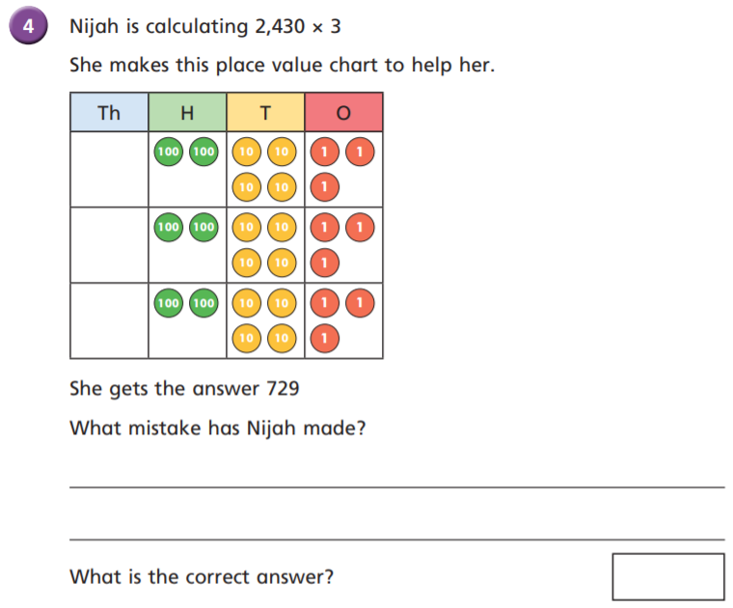

6639

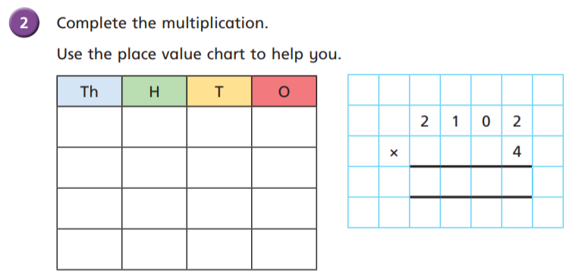

8 4 0 8

She hasn’t represented the digits from the multiplicand correctly. She needed to show ‘nothing’ in the ones to represent the place holder 0. She has calculated 243x3

7290

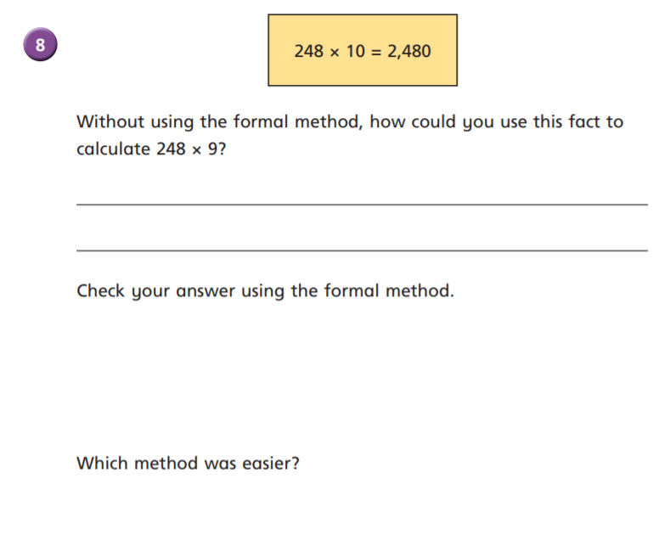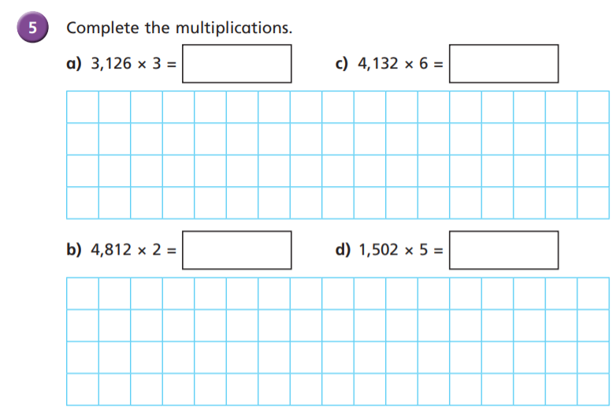

24,792

9378

If ten groups of 248 is equal to 2480, then nine groups would be one group of 248 less than this. 2480-248=2232

7510

9624

2 4 8

9 x

2 2 3 2

2 4 7

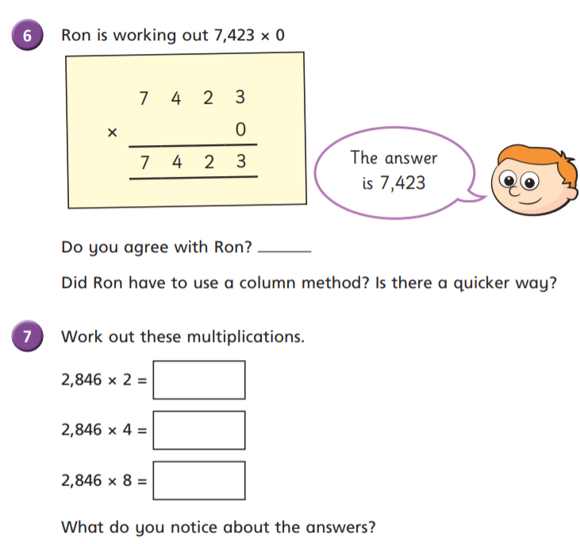

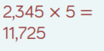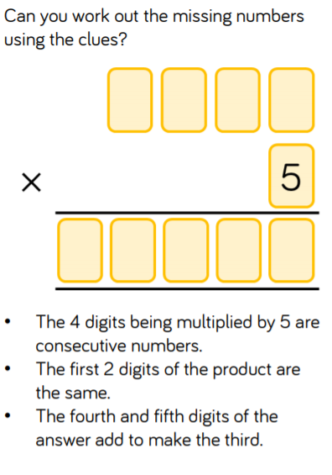

When one of the factors is doubled, the product doubles too.

22,768

11,384

5692

Any number made ‘0’ times is 0! 0 groups of 7423 is 0!

No!

See next page

for explanation



Consecutive numbers = numbers that follow each other. To create a 4 digit number these **could** be:

1234

2345

3456

4567

5678

6789

They can’t go any higher than this, the next in the sequence would have to be 78910 which would create a **5 digit** number

Try 1234 x 5 =

4 x 5 = 20

30 x 5 = 150

200 x 5 = 1000

So the 3rd, 4th and 5th digit of this answer would be 170 – this cannot be the missing factor then because the 4th and 5th digits (7 and 0) don’t add together to make the 3rd digit (1)

Try 2345 x 5 =

5 x 5 = 25

40 x 5 = 200

300 x 5 = 1500

So the 3rd, 4th and 5th digit of this answer would be 725 –so far so good because the 4th and 5th digits (2 and 5) do add together to make the 3rd digit (7)

Keep going!

2000 x 5 = 10,000

25 + 200 + 1500 + 10,000 = 11725

The first two digits of the product **are** the same

We’ve met all of the rules so the calculation was 2345 x 5 = 11725