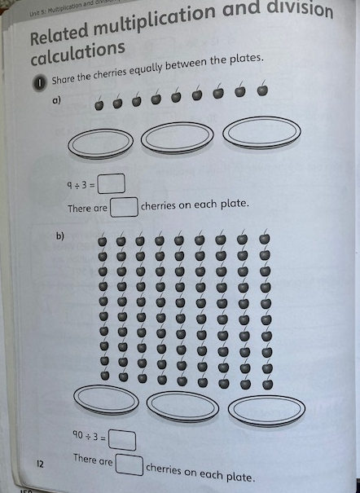

30

30

3

3

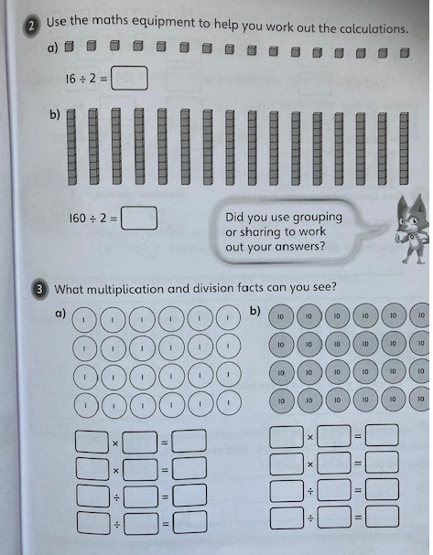

6

4

6

4

4

4

24

24

6

24

24

4

60

4

60

240

240

60

4

240

240

60

4

3

6

80

8

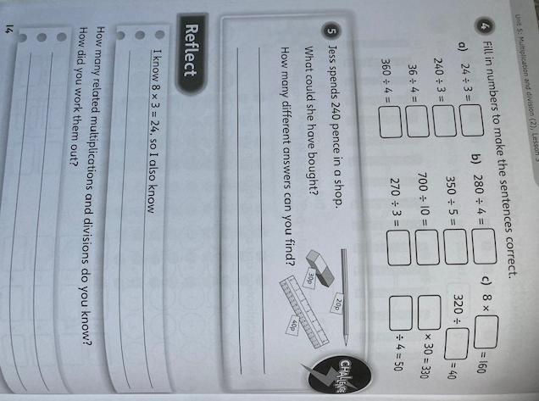

3 x8 = 24 24 ÷ 3 = 8 24 ÷8 = 3

3 x 80 = 240 30 x 8 = 240 240 ÷30 = 8

She could have bought 12 pencils or 8 rubbers or 6 rulers or a ruler and 10 pencils or a ruler and a pencil and 6 rubbers

200

11

8

20

70

50

70

90

8

80

9

90