08.01.21

LO: I can calculate perimeter.

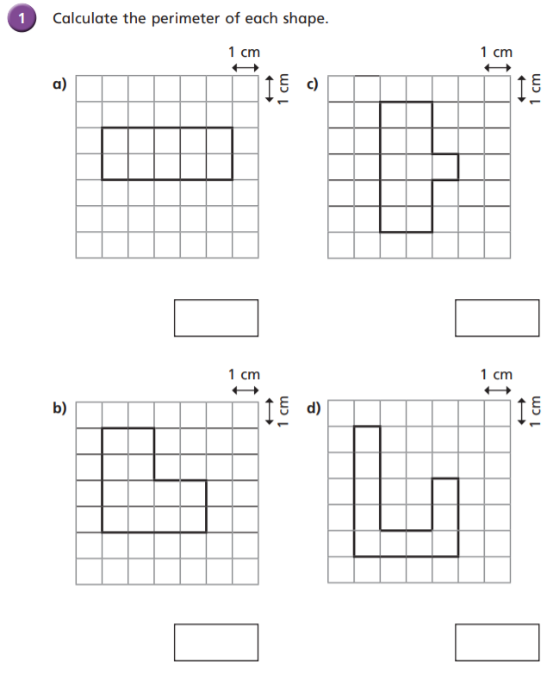

22cm

16cm

16cm

14cm

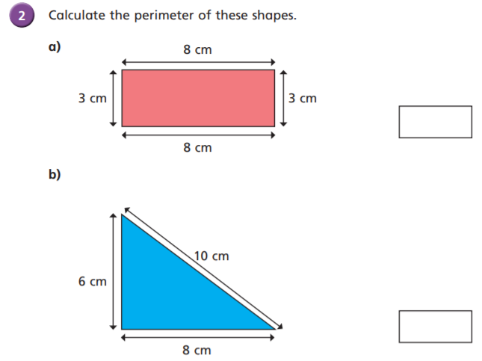

24cm

22cm

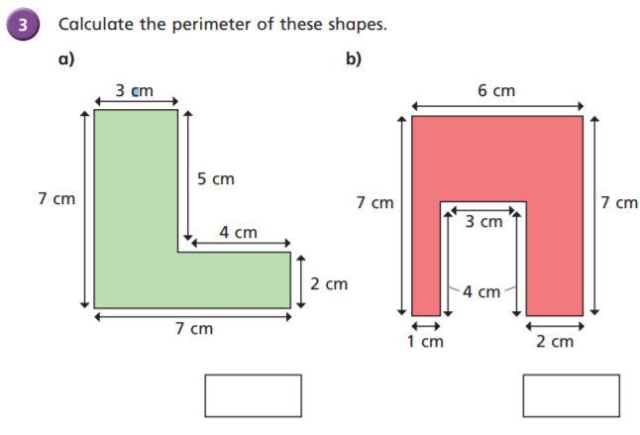

34cm

28cm

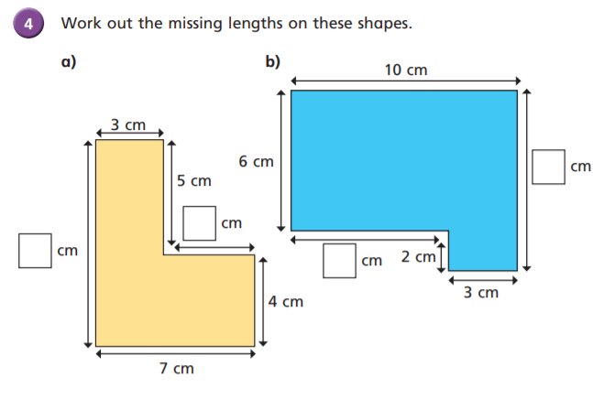

8

7

4

9

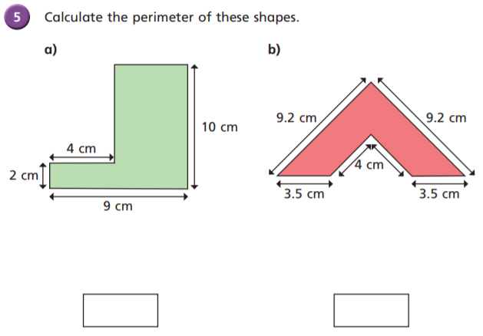

8cm

33.4cm

38cm

5cm

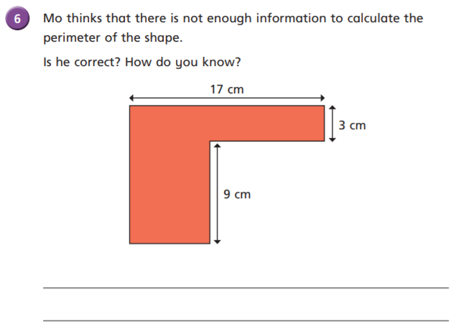

Mo is incorrect. We can identify that the missing vertical length can be identified through adding 9cm and 3cm to total 12cm and the missing horizontal lengths must total up to 17cm, so we don’t need to know their specific values. The perimeter is 58cm.

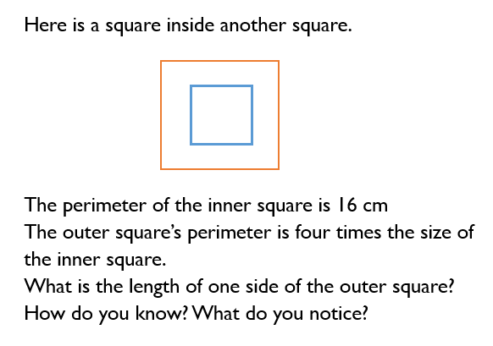

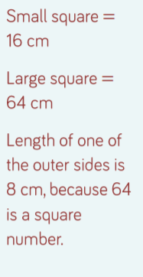

The length of one of the outer sides is 16cm. 64 divided by 4 = 16