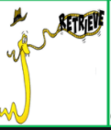
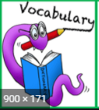
Tuesday 2nd February 2021
LO I can use my VIPER skills to answer retrieval and vocabulary questions.

- What are the main differences between an apatosaurus and a pterodactyl? (p 40 and 43) You could draw each and add labels to show how they are different.
- What is a herbivore? ( p 50)
- Is a pterodactyl a herbivore?
- Find and copy the simile used to describe the legs of the apatosaurus. (p 43)
- Think of a simile to describe the long neck of the apatosaurus. You could say the neck was as long as _________________ OR You could say the long neck was like _____________________________.

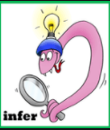
Wednesday 3rd February 2021
LO I can answer inference and vocabulary questions.

- Why do you think Banty's parents are called Titanic and Gargantua?
- Can you think of any other synonyms that mean the same as 'big'?
- Why do they call the daughter 'Banty'? (p42-3)
- Why are the pterodactyls and apatosauruses rude about each other?
- What does 'inferior' mean? (p39)
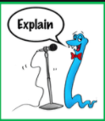
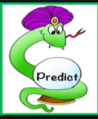
Friday 5th February 2021
LO I can retrieve from the text explain my answers and make predictions

- How are Clawed and Titanic similar?
- Why do apatosauruses have nostrils on the top of their heads? (p43-44)
- Why does Nosy say he is not strictly a dinosaur? (p 51)
- What does 'dino' mean?
- Why do you think the parents will not be happy that Nosy and Banty have been chatting?
- Do you think Banty and Nosy will be become friends?

