25.01.21

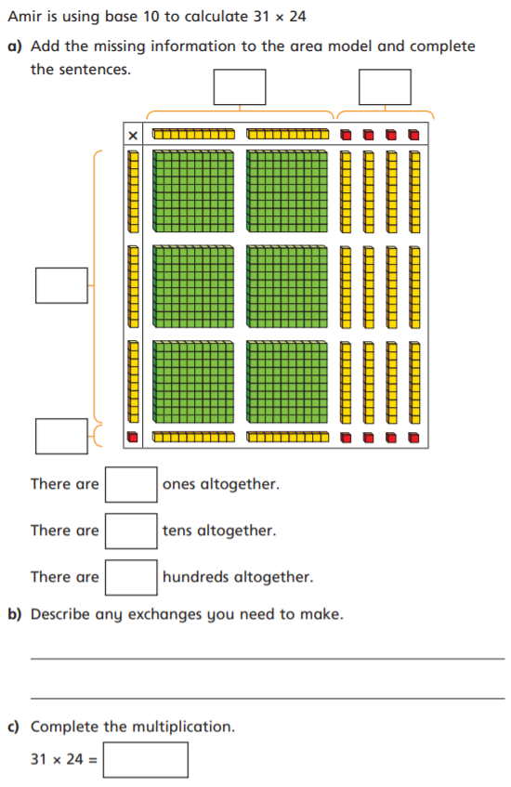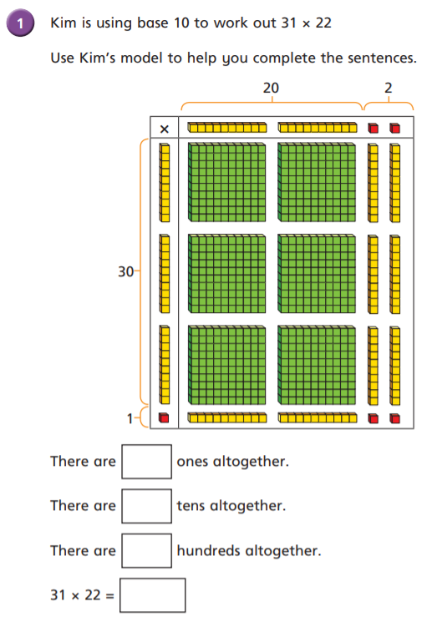LO: I can use the area model to multiply.



4

20

30

1

4

14

6

2

14 tens is 1 hundred and 4 tens

8

6

744

682

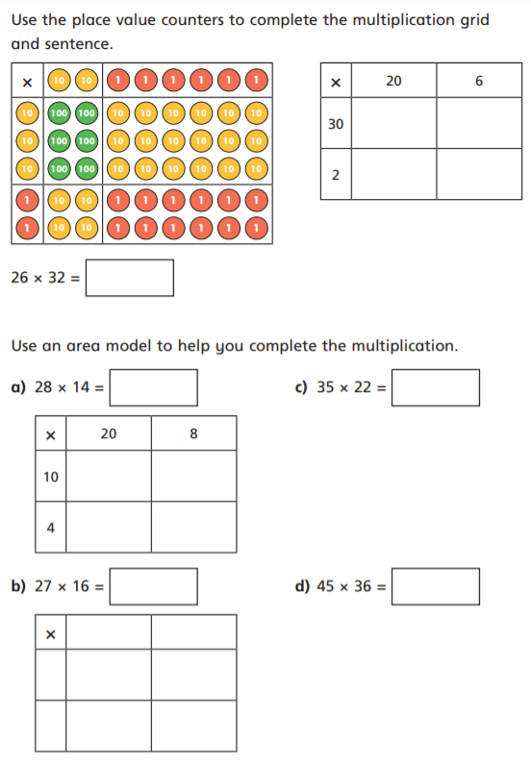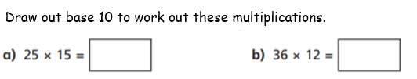

432

375

180

600

12

40

832



770

392

80

200

32

80

432

1620

7

20

70

200

10

42

120

6

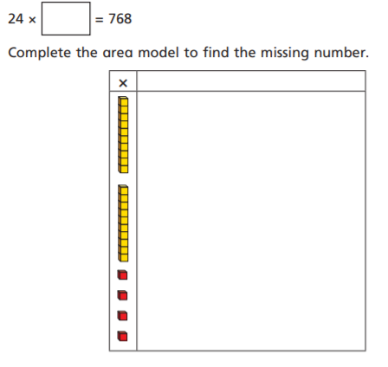

32

