Planning Chapter 2 with a twist.

Opening:
What is Hogarth doing at the start of your chapter?
Describe the IM in your own words.
Middle:

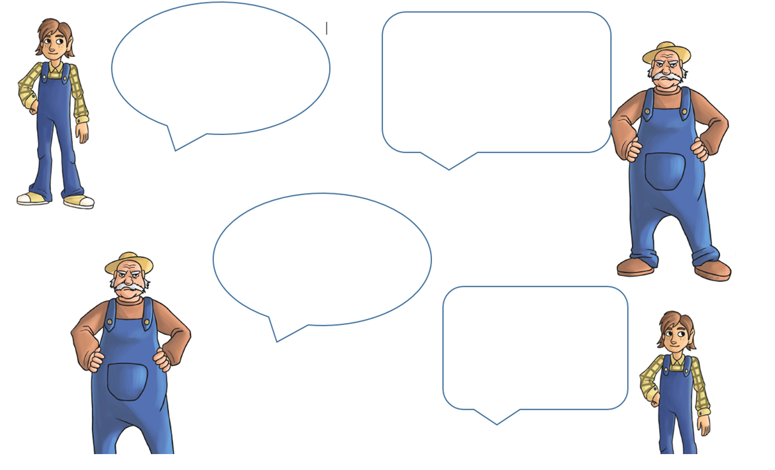

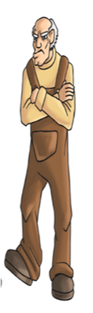
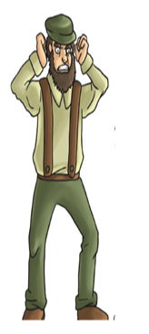

End:
The trap captures IM. How?
How does it make Hogarth feel?

