Story | Draw it | Write the  addition | Write the multiplication
There are 4 equal groups with 4 in each group. |  | 4 + 4 + 4 + 4 = | 4 x 4 =
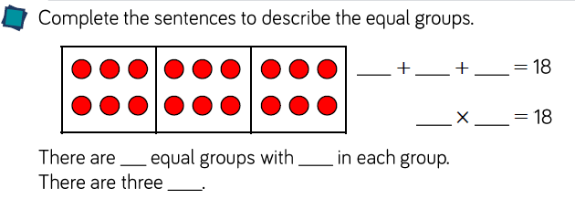

There are 5 equal groups with 3 in each group.

There are four 6s.

There are five 2s.

