27.01.21

LO: I can multiply a three-digit number by a 2-digit number.

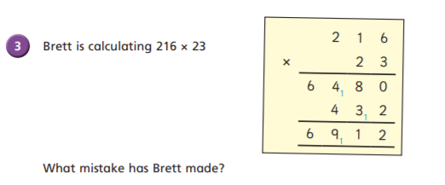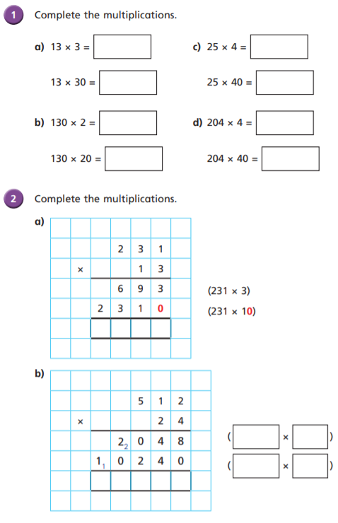

100

39

1000

390

816

260

8160

2600

He multiplied by 32 not 23.

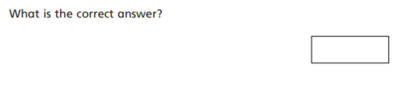

4968

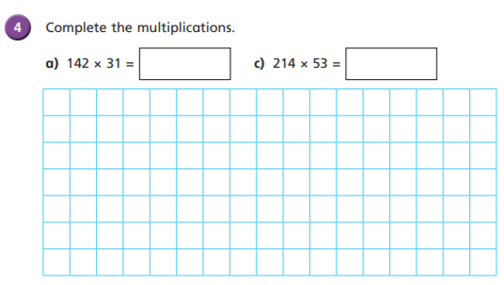

3 0 0 3

11,342

4,402

4

512

20

512

1 2 2 8 8

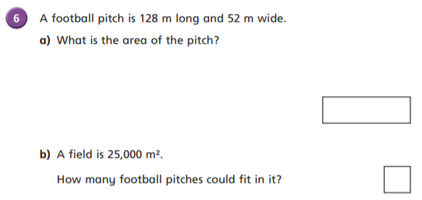 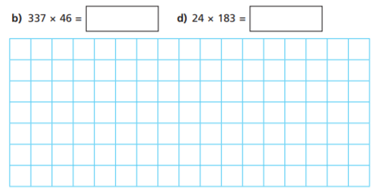

15.502

4,392

6,656m squared

3

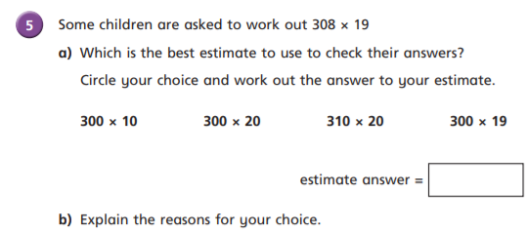

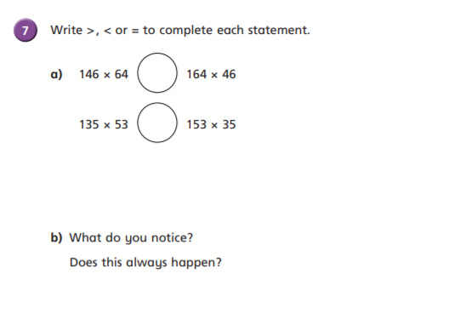

>

6,200

>

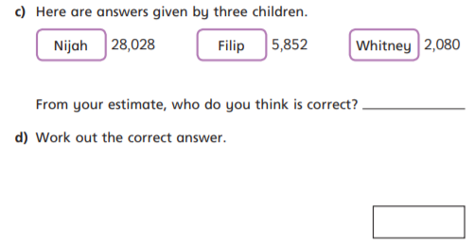

Filip

5,852

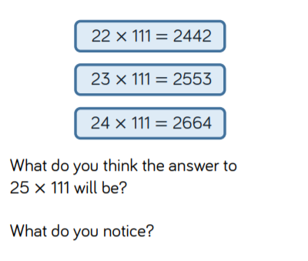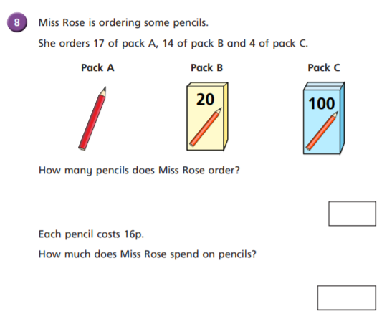

Pack A total = 17 pencils

Pack B total = 280 pencils

Pack C total = 400 pencils

2775

When you increase one factor by 1 and keep the other factor the same, the product increases by the consistent factor (the factor that has not changed).

11152p

£111.52

697 x 16p =

697