05.02.21

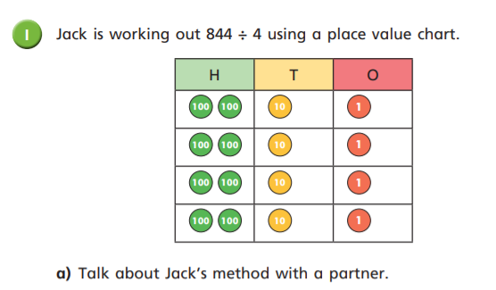LO: I can divide three-digit numbers by a one-digit number.

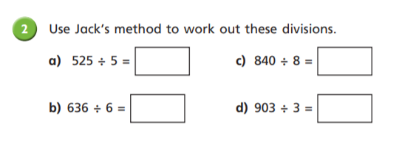

105

105

301

106

1. Describe Jack’s method. See if you can use the terms ‘dividend’, ‘divisor’ and ‘quotient’.

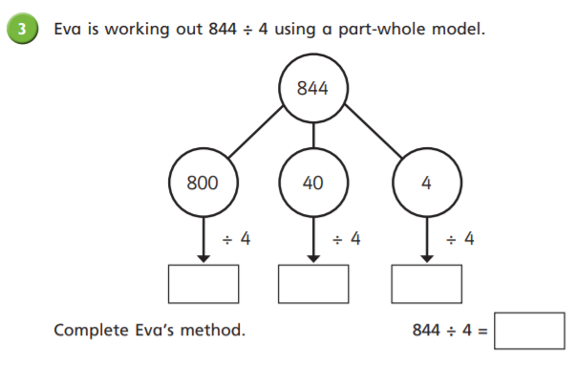

Jack splits the dividend into hundreds, tens and ones. He splits each of the components into 4 equal groups because 4 is the divisor. Each equal group contains two hundreds, one ten and one one so the quotient is 211

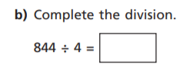

211

1

10

200

211

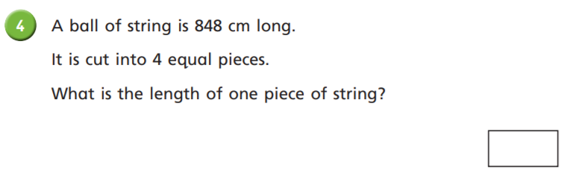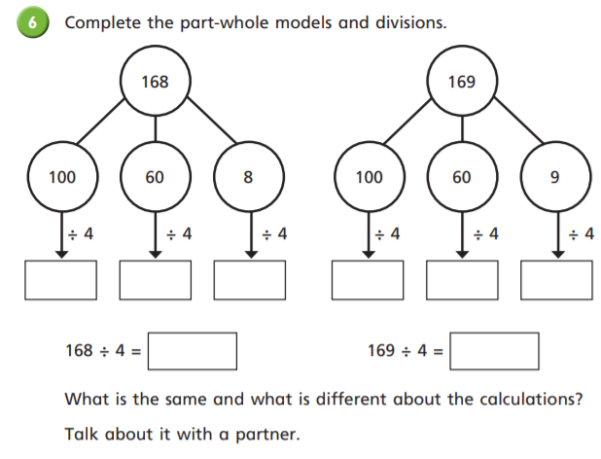

212cm

2r1

15

25

2

15

25

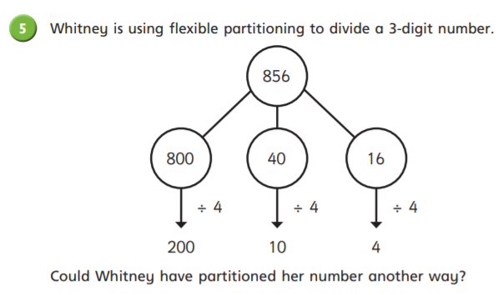

42r1

42

Show another way below.

169 is one more then 168, so when dividing both numbers by 4, you will get the same amount of equal groups and the ‘one more’ from 168 to make 169 becomes the remainder.

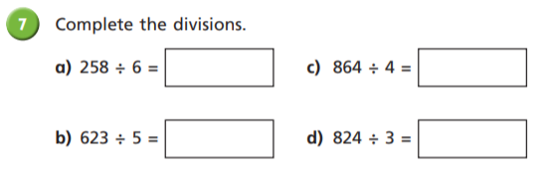

216

43

There are lots of different examples that you might have included here! Double check that you got the same answer as Whitney, that 856 divided by 4 = 214. If you did, your flexible partitioning worked!

274r2

124r3

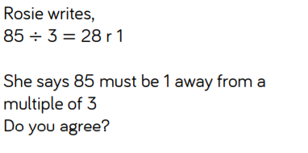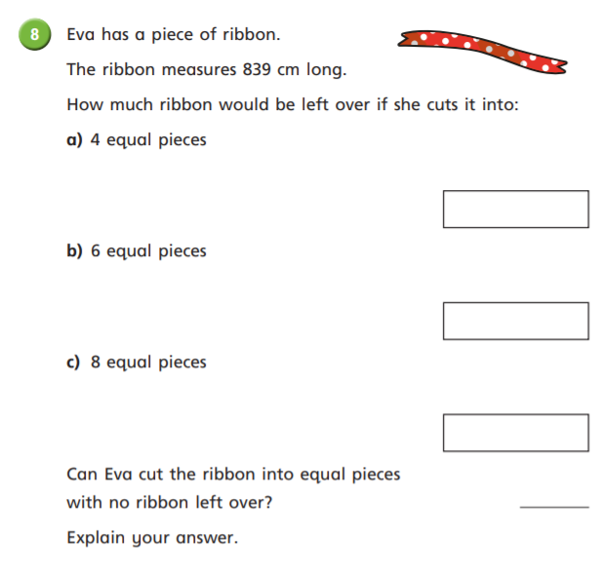

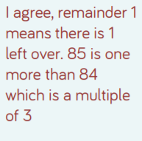

209r3

139r5

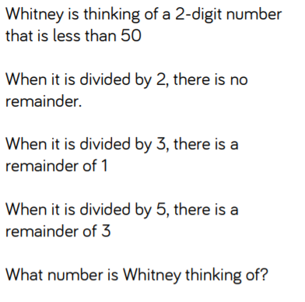

104r6

yes

She could cut her ribbon into 839 pieces, with each piece being 1cm long.

