Guided Reading Answers – Sir Isaac Newton

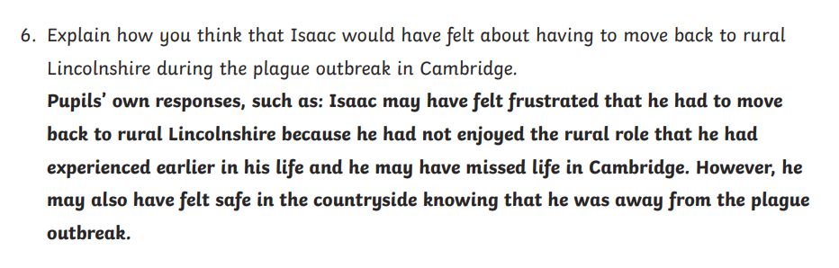

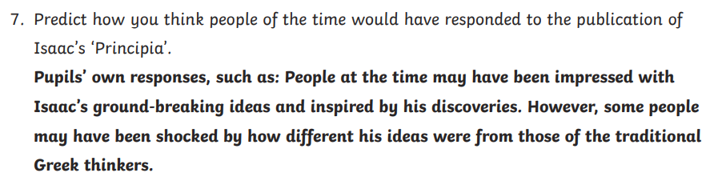

8. In your own words, explain the second law of motion using the sentence starter…
If an object’s mass is less (less heavy) it will need a greater force to move it or make it move faster.
(You might have explained that if something is heavier it requires a greater force to move it)

An adult at home will need to look at your final answer. They just need to have read the paragraph about the ‘second law of motion’ so that they can check your answer.

