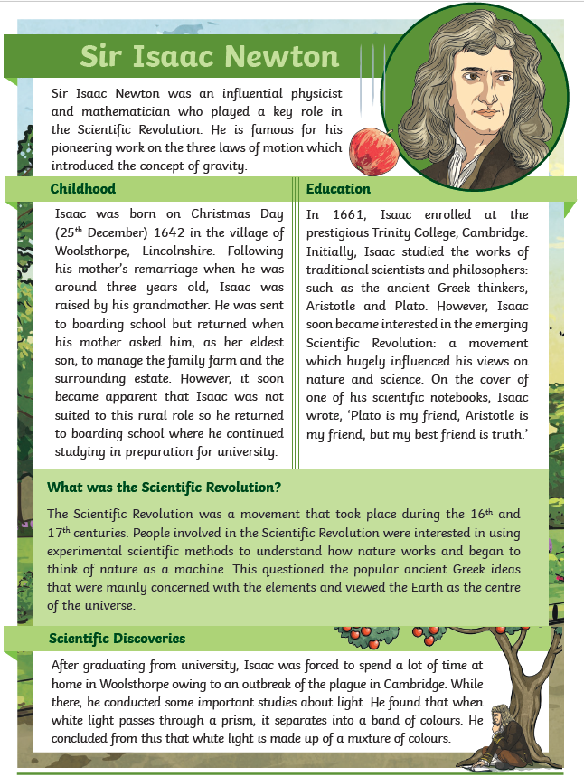

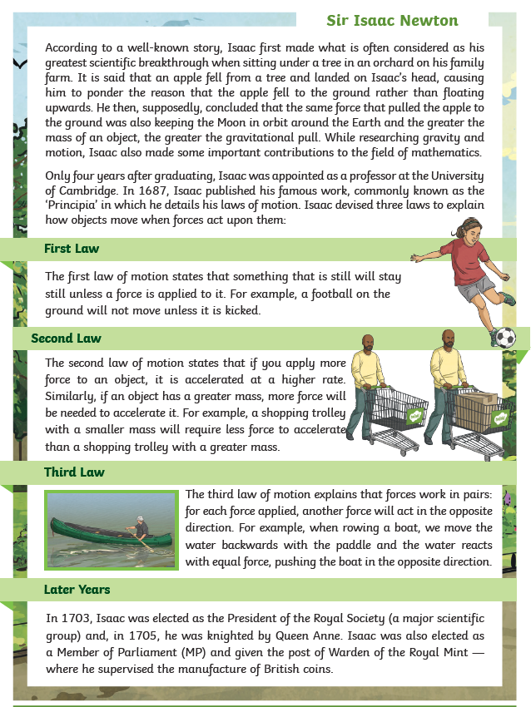

Tuesday 9th February 2021

Questions about Sir Isaac Newton.
Go back to the text to find the answers (or look for clues to write your answers).

6. Explain how you think that Isaac would have felt about having to move back to rural Lincolnshire during the plague outbreak in Cambridge.

________________________________________________________________________________________________________________________________________________________________________________________________

7. Predict how you think people of the time would have responded
to the publication of Isaac’s ‘Principia’.

___________________________________________________________________________________________________________________________________________________________________________________________________

8. In your own words, explain the second law of motion using the sentence starter…
If an object’s mass is less …_______________________________

Think of another example of the second law of motion. (Do not write an example from the text but use the text to guide you when thinking of an answer).
Write it below
________________________________________________________________________________________________________________________________________________________________________

