08.02.21

LO: I can divide four-digit numbers by one-digit numbers.

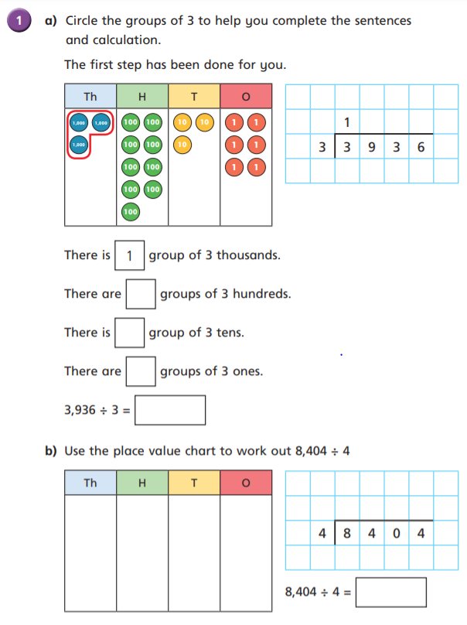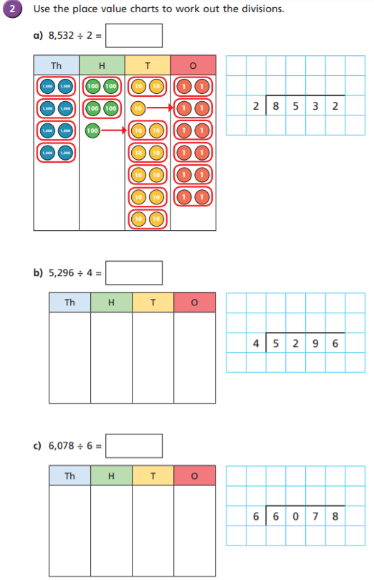

4266

1

1

4 2 6 6

2

1

3

1324

3

1 3 2 4

1

1

1

2

1312

1013

2 1 0 1

1 0 1 3

1

2101

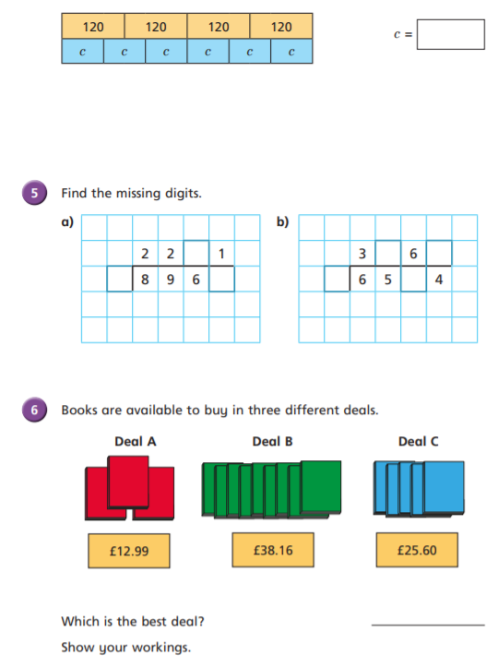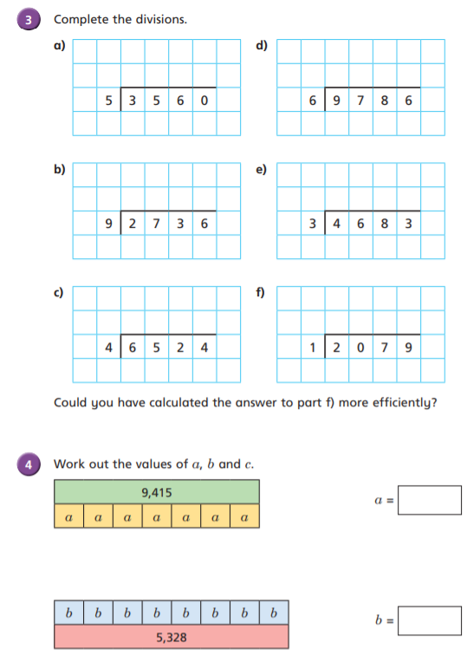  
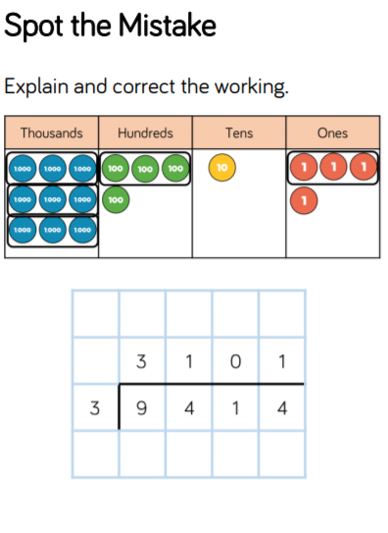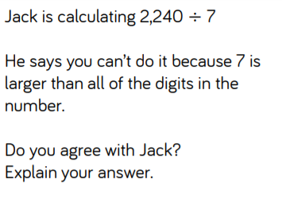

1

1

1

2

3

2

1

3

1

3

Deal B

£5.12 per book

£4.24 per book

£4.33 per book

2

2

2

2

4

4

4

80

666

1345

To divide into one equal group, means that all of your dividend is included in the same group! The quotient is the dividend.

2 0 7 9

1 5 6 1

1 6 3 1

1 6 3 1

3 0 4

7 1 2

