11.02.21

LO: I can apply my division knowledge to problem solving questions.



Use this rule to circle all of the divisions that have no remainder:

516 **÷**  4 = 1748 **÷**  4 = 938 **÷**  4 = ?04 **÷**  4 =

Circle the numbers that have no remainder when dividing by 5.

26 300 95 153 6045

Explain how you made your choices: ___________ __________________________________________________________________________________

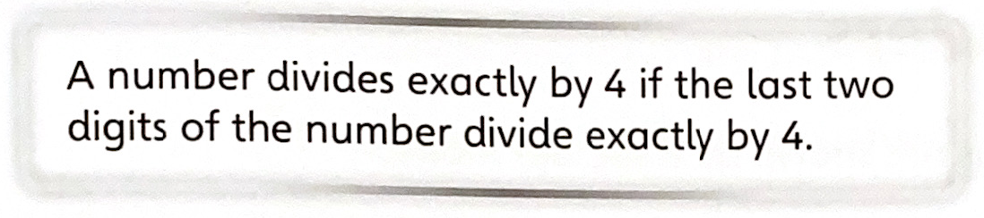

I know that any number that ends in 5 or 0 is a multiple of 5, so it can be split equally into 5 groups with no remainder.



Circle the numbers that have no remainder when dividing by 2.

1252 390 77 1001 788

Explain how you made your choices: ___________ __________________________________________________________________________________



Can you ever have a remainder that is higher than 8 when you divide by a 1-digit number? Explain why or why not.

I know that all even numbers are multiples of 2 so they can all be divided by 2 with no remainder.

No because if you are dividing by 9, the largest one-digit number, the largest remainder you could have would be 8, any number larger than this would allow you to give at least ‘one’ more to each of your 9 groups.

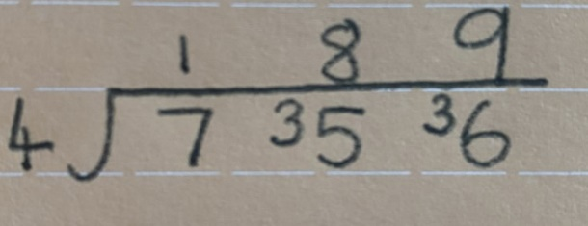

Show that there is no remainder when 756 is divided by 4:

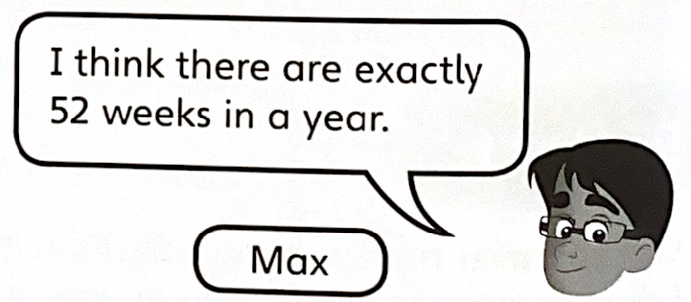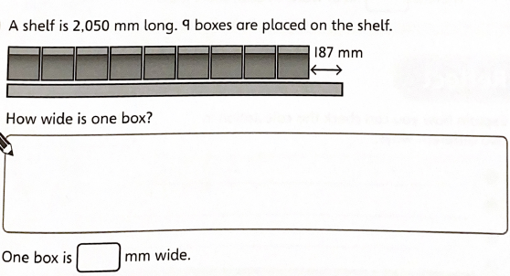

There are 365 days in a (non-leap) year and 7 days in a week…

2050-187=1863 (begin by removing the extra space)

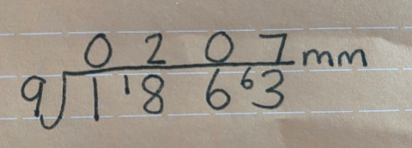

Show whether or not Max is correct.

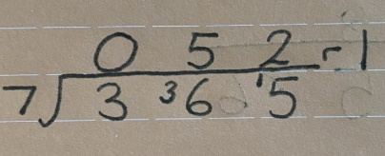

207



Max is incorrect there are 52 weeks and 1 day in a (non-leap) year.

A 5 litre bottle of water is shared between these glasses.

416ml of water is poured into each tall glass.

The rest of the water is shared equally between the short glasses.

How much water is in each short glass?

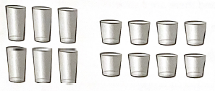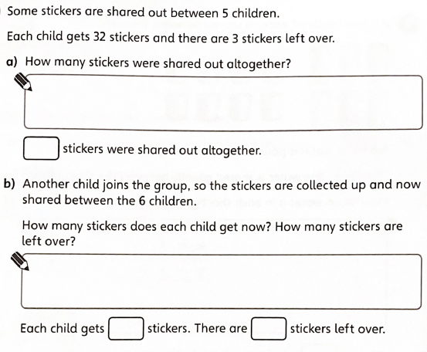

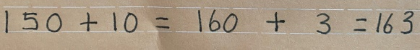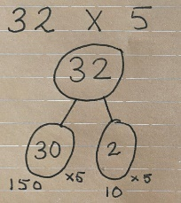

163 sweets are shared out altogether.

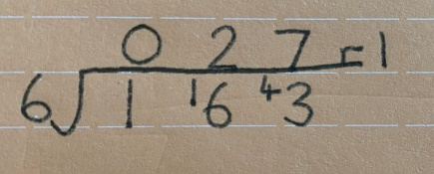

**313ml of water is poured into each short glass.**

5litres = 5000ml

416 x 6 = 2496

2496ml is taken up by the large glasses.

5000-2496=2504

There is 2504ml of water to be divided into the 8 short glasses

is 1 sticker

27

