11.02.21

LO: I can apply my division knowledge to problem solving questions.



Use this rule to circle all of the divisions that have no remainder:

516 **÷** 4 = 1748 **÷** 4 = 938 **÷** 4 = ?04 **÷** 4 =

Circle the numbers that have no remainder when dividing by 5.

26 300 95 153 6045

Explain how you made your choices: ___________ __________________________________________________________________________________

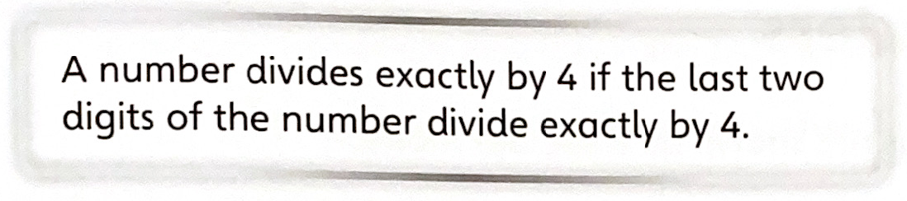



Circle the numbers that have no remainder when dividing by 2.

1252 390 77 1001 788

Explain how you made your choices: ___________ __________________________________________________________________________________



Can you ever have a remainder that is higher than 8 when you divide by a 1-digit number? Explain why or why not.

____________________________________________________________________________________________________________________________________________________________________



Show that there is no remainder when 756 is divided by 4:

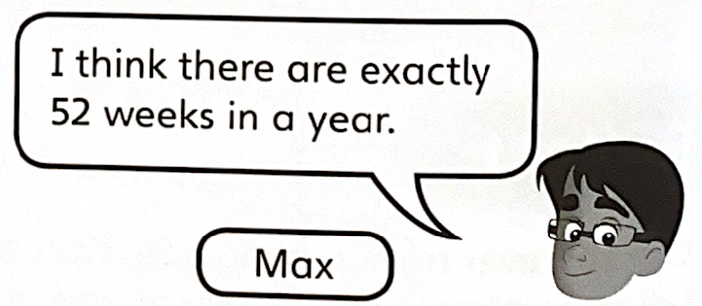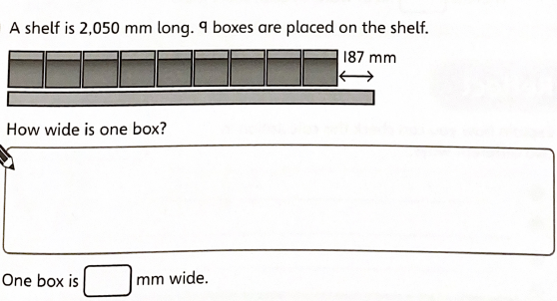

There are 365 days in a (non-leap) year and 7 days in a week…

Show whether or not Max is correct.



A 5 litre bottle of water is shared between these glasses.

416ml of water is poured into each tall glass.

The rest of the water is shared equally between the short glasses.

How much water is in each short glass?

