09.02.21

LO: I can divide 4-digit numbers by 1-digit numbers, including remainders.

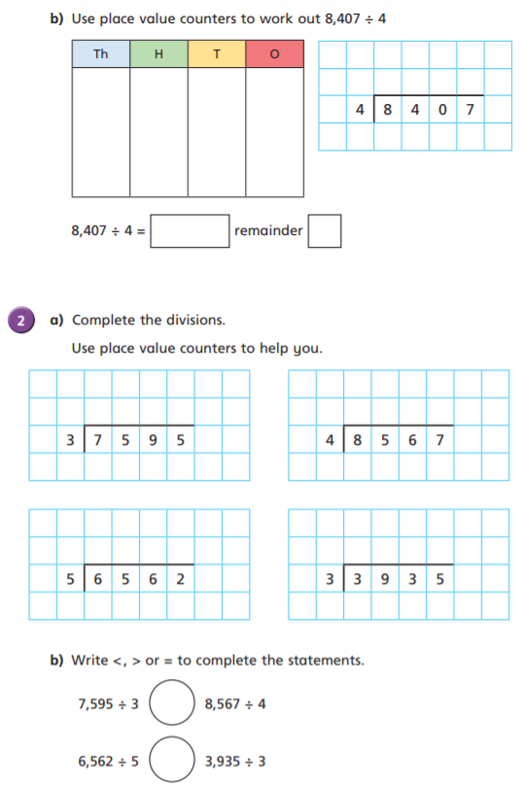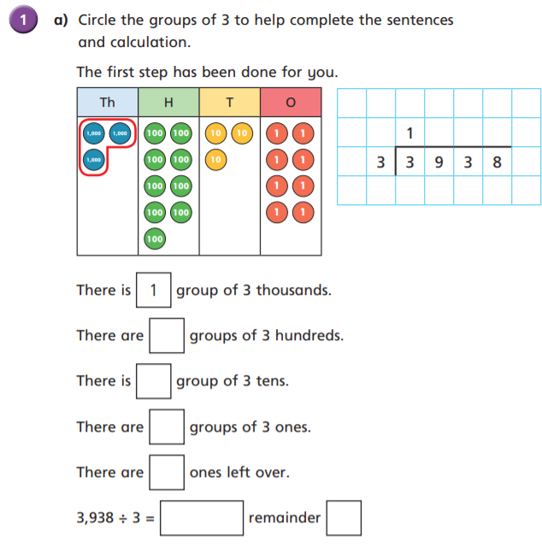

2 1 0 1 r3

3 1 2 r2

r3

2101

2 1 4 1 r3

2 5 3 1 r2

3

1

1 3 1 1 r2

1 3 1 2 r2

2

2

1312

2

>

>

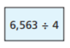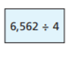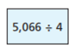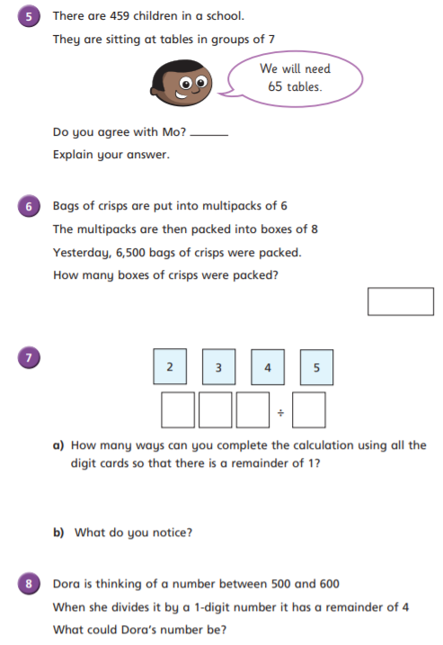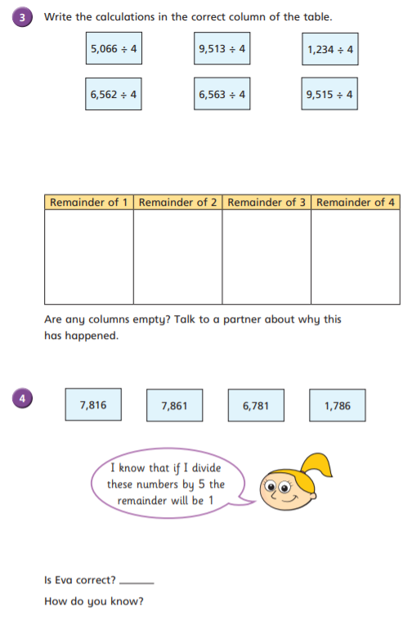

Again, there are lots of answers! Check your own calculation by doing the inverse operation and then adding your remaining 4! E.g 509 ÷ 5 = 101r4 so 101 x 5 = 505 + 4 = 509

There are multiple examples! Check your own answer by completing an inverse operation and adding on your remainder. E.g 435 ÷ 2 = 217r1 so 217 x 2 = 434 + 1 = 435

Did you notice things such as ‘odd numbers divided by 2 always have a remainder of 1?

Remember… you would only send out full multipacks/boxes to be sold, so you needed to ignore the remainder each time here.

135 boxes are packed.

There are 65 full tables of 7, but if he only has 65 tables, only 455 children will be able to sit down. Mo needs another table for the other 4 children, so he needs 66 tables.

No

Each of the numbers is 1 more than a multiple of 5. I know this because all numbers that end in 5 or 0 are multiples of 5.

Yes

Because is 4 is the divisor, the remainders must always be less than 4.

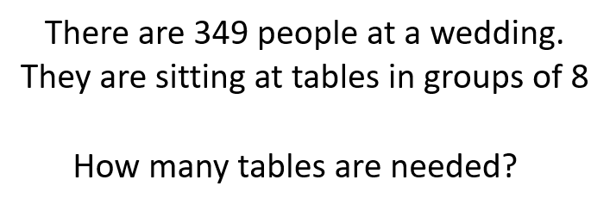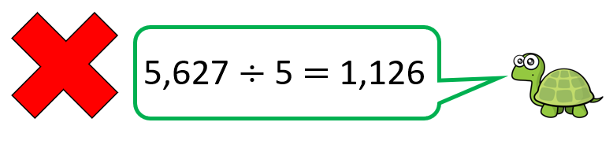

Use your knowledge of the 5 times table to explain why Terrance is incorrect. Can you use the word ‘multiple’ in your answer as well as referring to division being the inverse of multiplication?

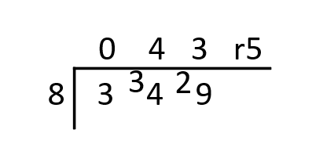

This calculation tells us that 5627 can be split into **5 groups of 1126**.

We know that multiples of 5 end in 5 or 0. So if we did the inverse of division and read this calculation backwards, as a multiplication question it would say 1126 x 5 = 5627 or **5 groups of 1126** = 5627. We would know that this isn’t correct, because 5627 does not end in 5 or 0! So, when I refer back to division, I know that if the dividend does not end in 5 or 0, it cannot be split equally into 5 groups.

Here, the dividend is 5627. To be able to split this into 5 groups, it would need to end in 5 or 0. This ends in 7. So I know that the nearest multiple of 5 must have been 5625, which tells me I will have remainder 2.

5627 ÷ 5 = 1125r2

1125 x 5 = 5625 + 2 = 5627

44 tables are needed so that all of the guests can sit down!