10.02.21

LO: I can divide 4-digit numbers by 1-digit numbers.



24r2

Complete the short division for 74 ÷ 3 =



Jamie shares 76 sweets equally among 6 of her friends.

How many sweets does each of her friends get?

Each friend gets ______ sweets.

There are ______ sweets left over.

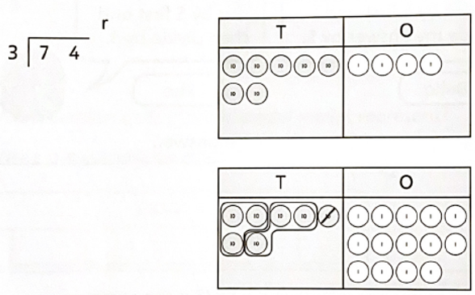

12

4

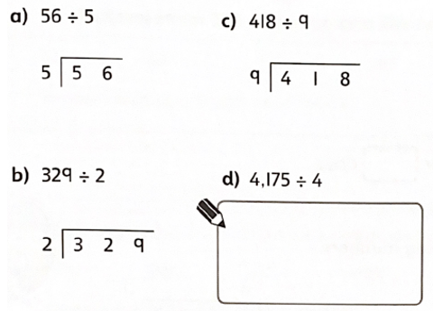

Work out these divisions:

=46 r4

= 11 r1

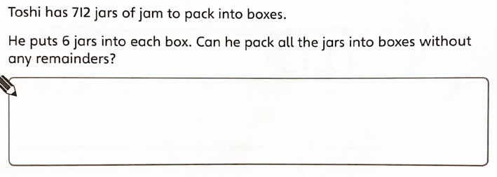

No, he can use 708 of the jars to pack 118 boxes, but he will have 4 jars remaining.

=1043 r3

= 164 r1

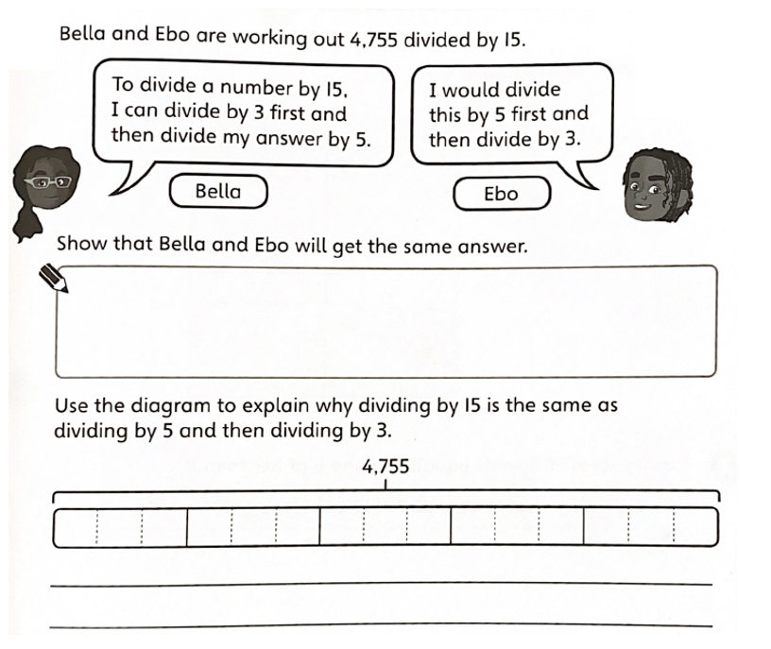

Kate says, ‘A remainder can sometimes be bigger than the number you are dividing by.’ Is she correct? Explain your answer.

___________________________________________________________________________________________________________________________

Katie is incorrect because if your remainder is bigger than your divisor, you have enough to give at least one more ‘one’ to each group.

4755 ÷ 5 = 951

951 ÷ 3 = 317

4755 ÷ 3 = 1585

1585 ÷ 5 = 317



Match each question to its remainder.

Are there any that you can match without working out the division?

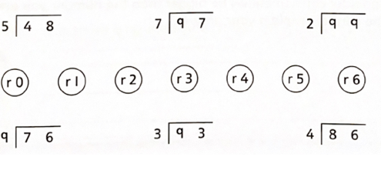

951

317

317

317

317

317

317

317

317

317

317

317

317

317

317

317

If you divide 4755 into 5 groups, each group is worth 951. If you then divide these 5 groups into 3 groups each, each group is worth 317. This leaves you with 15 groups of 317, which totals 4755. So if 317 x 15 = 4755, then 4755 ÷ 15 = 317.

I don’t think you needed to calculate any of them! I used my mental multiplication knowledge to help me. What you needed to understand was that multiples of any divisor, can be split into that amount of groups equally. If the dividend is not a multiple of the divisor, your calculation will include a remainder.

Here was the order I worked them out in:

The closest multiple of 5 to 48 is 45. 45 + 3 = 48. So 48 ÷ 5 must have had r3.

The closest multiple of 2 to 99 (without going above 99) is 98. 98 + 1 = 99. So 99 ÷ 2 must have had r1.

The closest multiple of 3 to 93 is 93. So 93 ÷ 3 doesn’t need a remainder.

The closest multiple of 4 to 86 (without going above 86) is 84. 84 + 2 = 86. So 86 ÷ 4 must have had r2.

The closest multiple of 9 to 76 is 72. 72 + 4 = 76. So 76 ÷ 9 must have had r4.

The closest multiple of 7 to 97 (without going above 97) is 91. 91 + 6 = 97. So 97 ÷ 7 must have had r6.

On **Q6**, please don’t worry if you needed to calculate some of the questions to find the remainder 😊 If you were able to match them, then you can tick your answers!