02.03.21

LO: I can explore number sequences, which involve fractions.

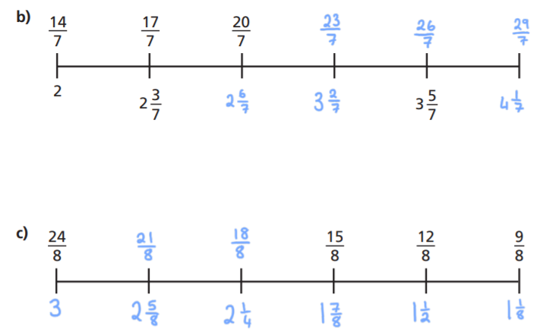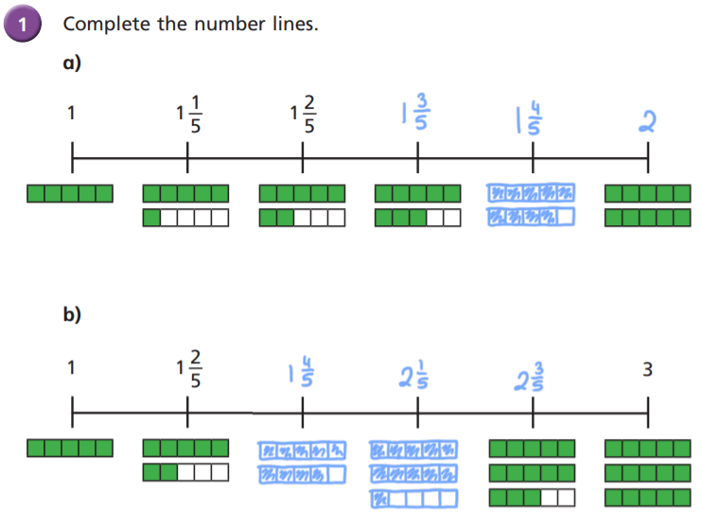

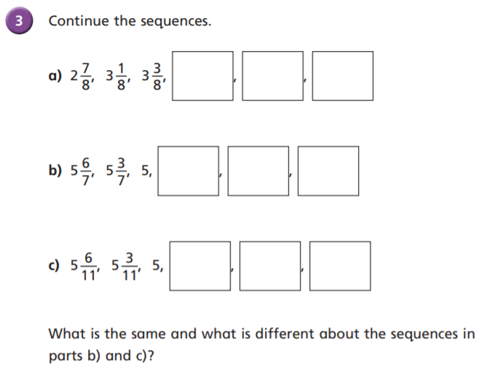

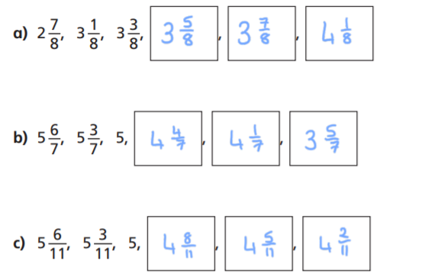

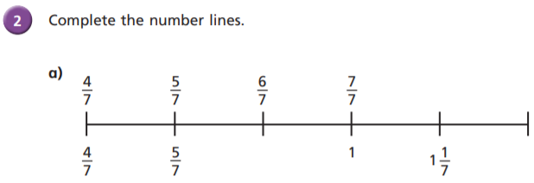

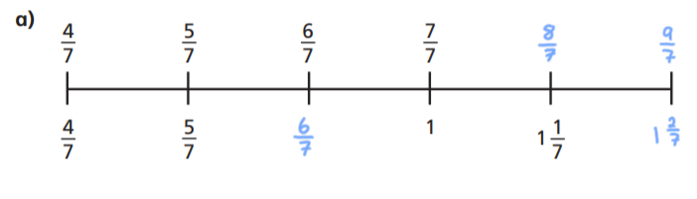

I wonder what you noticed? Perhaps you made comments such as ‘they are both decreasing by ‘3’ parts each time. Maybe you could share your comments with somebody at home today.

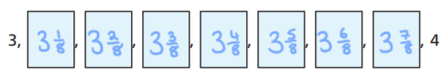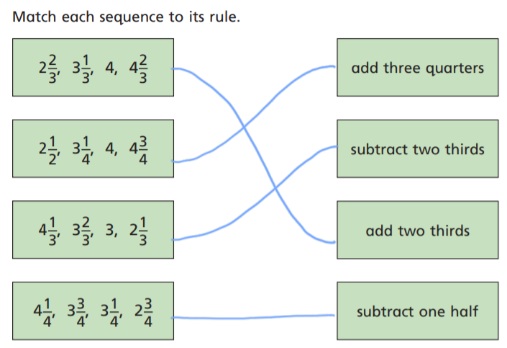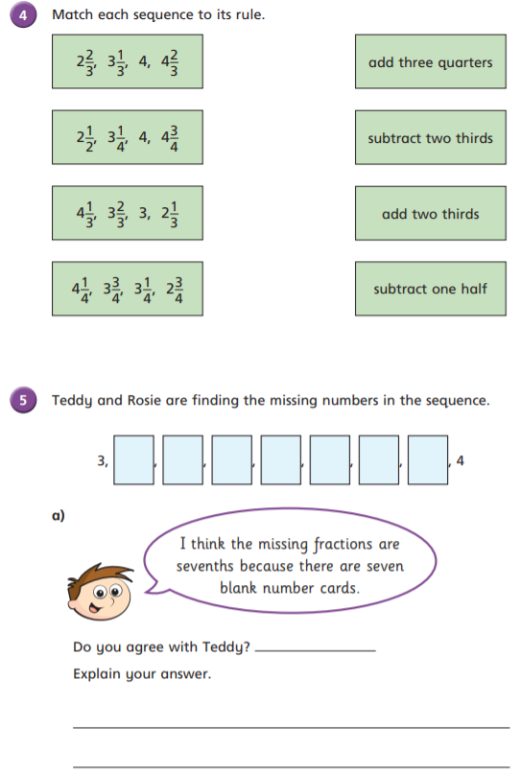  
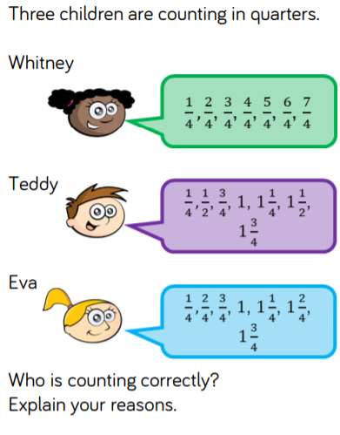

Either add or subtract one third.

$\frac{4}{8}$ is equivalent to $\frac{1}{2}$. So 3 $\frac{4}{8}=3\frac{1}{2}$

Yes

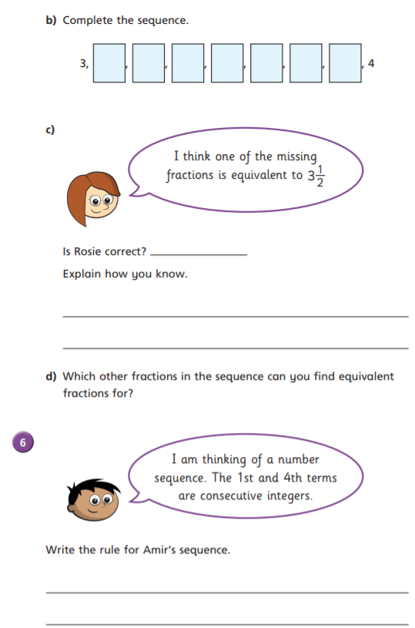

There are 7 cards between 3 and 4. If they were sevenths, there would only be 6 cards because on Teddy’s 7th card, he will write 3 and 7 sevenths, which is equal to 4.

No

They are all correct!

Whitney has counted in quarters, using improper fractions.

Teddy has counted in quarters, using equivalent fractions to show that $\frac{2}{4}$ = $\frac{1}{2}$ and has also used mixed numbers.

Eva has counted in quarters, using mixed numbers.