Dear Parents/Carers,
We would like to let you know about our exciting topics for this half term in Year 2
‘Wonder Women’
We are looking at the lives of significant individuals in history, their impact on the world and the legacy they left.
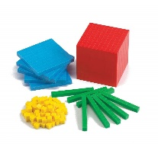  Maths | 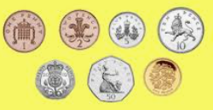  Number: Addition and subtraction  Measures: Money  Multiplication and division
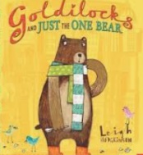  Literacy | We are writing to inform:  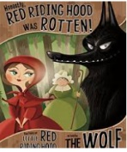  A non-chronological report about Florence Nightingale – using sub-headings and organising information in chronological order.  We are writing to entertain:  We will be re-writing traditional fairy tales with an alternative twist.
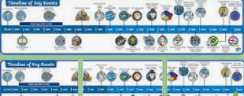  History | This topic starts with our Hero Day  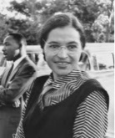  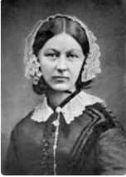  The lives of and achievements of women who have changed the world.  We will study: Florence Nightingale, Grace Darling, Rosa Parks, Emeline Pankhurst, Ada Lovelace and Greta Thunberg.
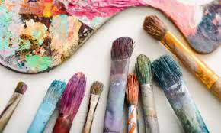  Art & DT | 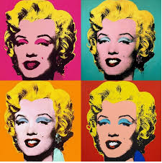  Photography and Printing:Pop Art and Andy Warhol  We will be taking photographs and producing a mono-print of ourseleves in the style of Andy Warhol
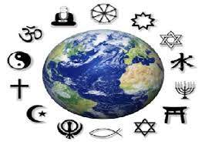  RE | Celebrations: Eid and Christmas  We will be looking at similarities in celebrations
PE | Games  We will play and learn tactics for a variety of invasion games as well as practising a range of skills.  PE will remain on a Tuesday and Wednesday this half term (please send your child in warm PE kit on a Wednesday as they will still be going outside)
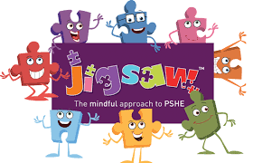  PSHE | 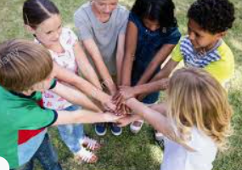  Celebrating Differences (Jigsaw)
ICT | 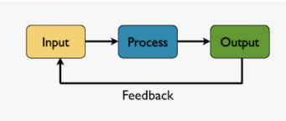  Programming: Coding  Inputs and controlling movements on screen  Internet research  Keeping everyone safe online
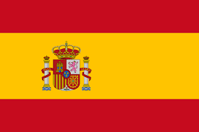  Spanish | I can…

