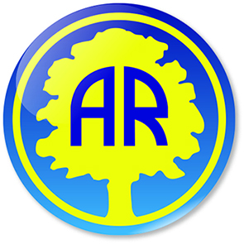
Welcome back letter
Year 3 Summer 2 2022
Dear Parents and Carers,
Welcome back! We hope you had a ‘jubilant’ half term and the children feel relaxed and rested, ready for an action-packed Summer 2! Our Extreme Weather topic is a lot of fun and of course, we have Camp Redwood to look forward to!
In anticipation of warmer weather, please make sure your child is wearing sunscreen before they arrive at school and has a sunhat to wear when outside.
Here are some details about what we will be learning over the coming weeks and some further information you may find useful:
PE will continue to happen on a Wednesday afternoon with Mr. Haxby from Premier Sports and on a Friday afternoon. 3M and 3SP will be doing PE outside on a Friday afternoon as we start our Tennis unit.
Homework:
- Spellings will continue to be set on a Thursday to be tested the following Wednesday. These will be linked to spelling shed and stuck into the reading diaries each week. On test day, the children will write their spellings in their diaries so you can see how well your child did each week.
- We expect your child to read at least 3 times a week and for this to be recorded in the diary, even if your child is a fluent reader. Children can record independently if you so wish.
- This half term we will be looking at time, so please give your child plenty of opportunities to tell you the time, using an analogue and digital clock.
- Please continue to practise times tables at home using Timetables Rockstars as it has made a huge impact on the children’s confidence and recall during our maths lessons. They really enjoy it too!
- An additional piece of work will be given on a weekly basis to support children’s learning. This would usually be an English, Maths or Topic related task. This will be given in a homework book. Homework will be set on a Thursday and should be returned by the following Wednesday.
Children continue to have a range of reading activities on a daily basis, including whole class reading. Your child will have an opportunity to change their book regularly. Reading books and Reading Diaries should be in school at all times and parents are expected to sign and comment on reading at home at least weekly. These books are also a great opportunity to pass messages to us. We encourage children to show us if there is a note from home that needs our attention.
Please don’t forget to add your child’s reading achievements to the Million Page reading target on the website!
This half term Year 3 will be doing many exciting learning challenges. We will be covering:
English   | Writing to explain:  Explanation text- how a tornado is formed.  Writing to inform:  Newspaper article reporting an extreme weather event.  Storm chaser diary entry / account  Writing to entertain:  Extreme weather poems.
Whole Class Guided Reading  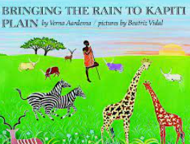 | The children will practise using their VIPER skills and echo reading skills using:  - Non-fiction extreme weather reports.  - Bringing the rain to Kapiti Plain
Maths  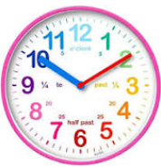 | Measurement involving:  - Time  - Properties of shape  - Measurements
PE  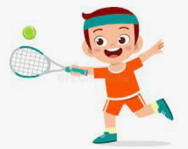 | Tennis:  - Rules of the game  - Racket and ball skills
Spanish  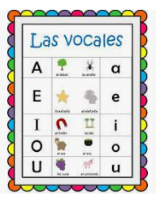 | Core Vocabulary:  - ‘Spanish Phonetics’  - Vowels  - Consonants
Science   | Forces and Magnets:  - Compare how things move on different surfaces  - Observe how magnets attract or repel each other and attract some materials and not others  - Compare and group together a variety of everyday materials on the basis of whether they are attracted to a magnet, and identify some magnetic materials  - Describe magnets as having two poles  - Predict whether two magnets will attract or repel each other, depending on which poles are facing.
Art  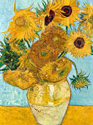 | Painting:  Explore creating different textures with paint.  Artist focus – Van Gogh
RE
Geography  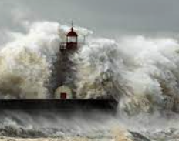 | Extreme Weather:  Enquiry: What extreme weather do we have in the UK?
PSHE  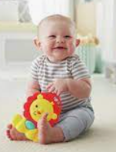 | Changing Me:  How babies grow  Understanding a baby’s needs  Outside body changes  Inside body changes  Family stereotypes  Preparing for transition
ICT   | Research and present:  Locate a webpage using a URL (web address) find and save appropriate images / text from the internet in their work.  E-safety:  - Understand the term ‘digital footprint’  - Know what is ok to share online about yourself  - Who does your image belong to?  - When your photograph is taken, or you take a photograph of someone, who owns that image?
Music  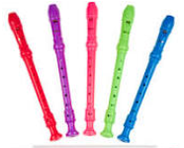 | Singing and Recorders:  Three Little Birds Charanga unit

It looks set to be a very busy half term! Especially with Camp Redwood on the horizon! 😊
Mrs Phillips, Mrs Seagrave, Miss Moore, Mrs Slack and Miss Angel

