Dear Parents/Carers,
We would like to let you know about our exciting topics for this half term in Year 2
‘How have these wonder women changed the world?’
We are looking at the lives of significant individuals in history, their impact on the world and the legacy they left.
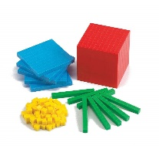  Maths | Time: O’clock  Number: Addition and subtraction  Shape
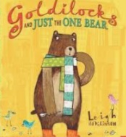  Literacy | We are writing to inform:  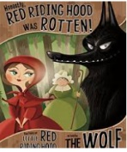  A Chronological Report about Florence Nightingale – using sub-headings and organising information in chronological order.  We are writing to entertain:  We will be re-writing traditional fairy tales with an alternative twist.
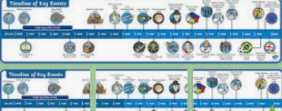  History | This topic starts with our Hero Day  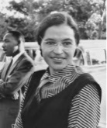  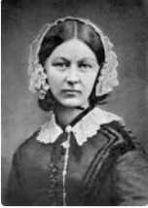  How have these wonder women changed the world?  We will study: Florence Nightingale, Grace Darling, Rosa Parks, Emmeline Pankhurst, Ada Lovelace, Queen Elizabeth II and Greta Thunberg.
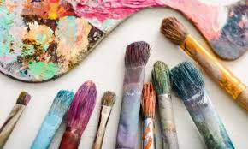  Art & DT | 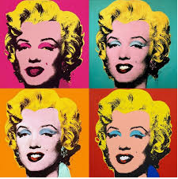  Photography and Printing:Pop Art and Andy Warhol  We will be taking photographs and producing a mono-print in the style of Andy Warhol  DT: We will be creating a moving picture using mechanisms of Levers and sliders
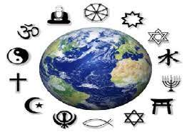  RE | Celebrations: Eid and Christmas  We will be looking at similarities in celebrations
  PE | Fitness and Ball skills  PE will remain on a Tuesday and Wednesday this half term (please send your child in warm PE kit as they will still be going outside)
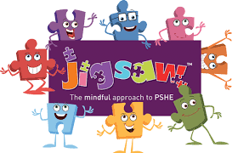  PSHE | 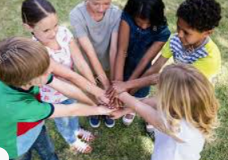  Celebrating Differences (Jigsaw)
  ICT | E-safety – online bullying  Typing and Mouse skills – logging on to I-pads and laptops  Word processing skills – popplet  Images – taking images and altering them using filters
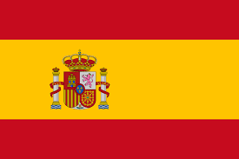  Spanish | Numbers

