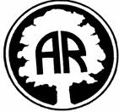
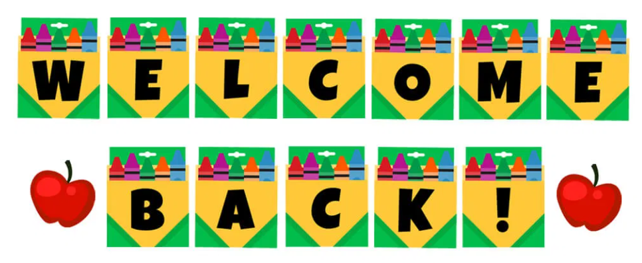

January 2023

Dear Parents/ Carers,

Happy New Year and welcome back to Year 2! We hope you have had a wonderful Christmas break!
Thank you!
The Year 2 team thank you for your kind Christmas wishes and gifts – as always it is never expected but always much appreciated. We had a great time celebrating Christmas with the children in school, especially our wonderful Nativity. We were most impressed with their Christmas cards with moving parts – we hope you enjoyed receiving them!
Our learning:
We had a great Autumn 2 half term, and the children relished our history topic, How did these Wonder Women change the world? learning about significant women who have changed history. From the topic, the children produced some wonderful pieces of written historical enquiry, as well as creating some magnificent mono-prints.

Our Spring 1 topic, Animals including Humans, promises to be just as fun and we are looking forward to exploring it with our Year 2 scientists! Highlights of this topic include writing a story about a magical potion linked to George’s Marvellous Medicine, designing a healthy wrap and drawing fruit in the style of Paul Cezanne. Oh, and fencing with Miss James. What’s not to love? We cannot wait!

For more insight into what we will be covering in all our subjects this half term, please refer to the curriculum coverage letter.

Following is some additional information about Year 2 that – although some of it is repeated - you may find useful.

Drop off and collection of pupils:
The timings are to remain the same. Just a reminder:
Drop off: 8.40-8.50
Please note: It is important that your child is in school by 8:50, as we are ready to start the Register and our Guided Reading lesson
Collection: 3.25 – 3.30
Should you wish for your child to be picked up by another adult, we will need written permission.
Fruit:
Just to remind you that fruit is available at school. If you wish to provide an alternative snack, we ask that it is a healthy option.

PE:
We will continue to teach PE twice during the week, on Tuesdays and Wednesdays. Please can you make sure your children come dressed for PE on both days. On these winter days, they will need to wear dark jogging bottoms or leggings, a white t-shirt, a dark jumper/hoodie and trainers.

Reading:
We were delighted with the progress children made in their reading during the Autumn term. Thank you for working so hard to read with them at home on a daily basis, it really does make a difference in their reading, which in turn, massively supports their writing. Please sign the reading diary when you have heard your child read and ask your child lots of questions about their book to help their understanding. Ideas can be found on the reading target attached to your child’s reading diary. The children are encouraged to change their books regularly throughout the week.

Following morning registration, we continue to conduct whole class guiding reading in which they develop their comprehension skills.

Ed-shed and Numbots:
It was great to see how independent the children became in using the school laptops and logging in to Ed-shed in the Autumn Term! Please continue to encourage your children to use it weekly to practise the spelling pattern of the week and we will be introducing Numbots this half term.

It promises to be a busy and action-packed half term!

Kind regards,

The Year 2 Team

