Year 2 Curriculum Coverage: Spring 1 2023
Here is some information about the topics we will be covering this half term.
Literacy  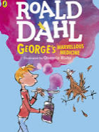 | Letters:  The Day the Crayons Quit  Letters for different purposes  Narrative: George’s Marvellous Medicine  An alternative description of what happens to Granny  Instructions  Making a healthy wrap
Maths | Time – half past  Addition and Subtraction  - Adding and subtracting one digit from a two-digit number  - Adding and subtracting two digits from a two-digit number  Money  Please practise using real money at home  - making amounts, adding amounts  - giving ‘shopkeepers’ change
Science  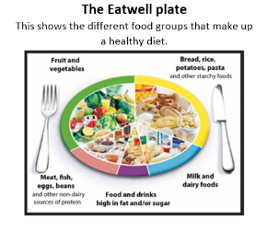 | Animals including Humans  We will find out what animals and humans need to survive.  We will describe the importance for humans of exercise and learn about different food groups and eating the right amounts of different types of food.  We will also investigate the importance of washing hands when preparing food and general hygiene.
Art  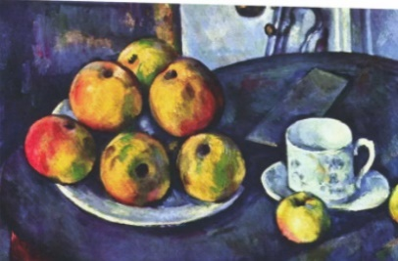 | Still life – drawing  We will be looking at still life images of fruit and vegetables.  We will focus on the work of Paul Cezanne.
DT | Food – making a healthy wrap  Design, make and evaluate a variety of food in both taste and texture to create our own healthy and tasty wrap.
Spanish  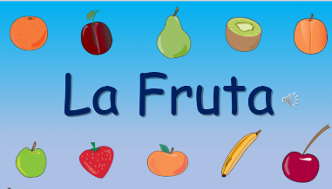 | La Fruta  Learning and using the vocabulary for fruit.
Computing  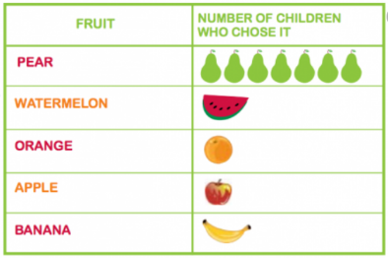 | Data collection – Making a Pictogram  Logging on to Numbots
RE | Jesus’ friends and followers
PSHE | The Jigsaw scheme  Dreams and Goals
PE | Fencing  Sending and Receiving

PE lessons – Tuesdays and Wednesdays: Please make sure that your child wears their warm PE kit with trainers, as the children will be going out in all weathers.
Homework – tasks will be sent out on a Thursday / Friday to be returned by the following Thursday unless otherwise specified.
Ed Shed – weekly assignments to practise the spelling pattern of the week
Numbots – play weekly to improve basic maths fluency

