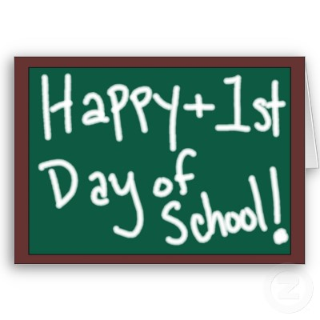

How to have a happy first week at school!

* Always be positive when talking to your child about school.
* Say a quick and positive goodbye. We will call you if we need you.
* Read the letter carefully to ensure that you are at the right session on the right day and are on time to pick up your child.
* Label ***everything*** even shoes and socks if you want the right ones back!
* Your child will come to school dressed in PE kit on PE day

This will not be the first week. We will let you know when PE is.

* Get into the good habit of bringing book bags every day.
* Check your child’s book bag for letters every night and read all emails.
* Put a keyring on your child’s book bag to help them identify theirs.
* Bring a water bottle with name on every day.
* Do not put water bottles in their book bag, in case it leaks.
* Please send a note or tell us if your child is going home with someone different. We cannot let your child go with any other adult without your consent.
* Please come forward to collect your child at the end of the day.

We are all looking forward to a happy, fun first week at school!