September 2023

Dear Parents/Carers,

We are delighted with how well your children have settled into Year 1. We hope they have had a happy first few days. We hope to see lots of you tonight at the information meeting at 6pm in the school hall.

PE days
We have PE on Monday and Thursday. Please wear PE kits to school on these days.
- White t shirt or navy ‘Abbey Road’ t shirt
- Navy/black shorts or navy/black joggers/leggings
- Trainers / plimsolls
- Plain navy/black sweatshirt or hoodie
- No earrings

Other information
- Please send a water bottle every day
- Please name all items of clothing
- School fruit is delivered every day so unless your child doesn’t eat the school fruit there is no need for snacks to be brought in (Please ensure all snacks are healthy eg chopped grapes, raisins, dried mango)
- Reading diaries should be in book bags every day please
- Milk should be ordered online (usually takes 2 weeks to be on the system)
- Our email address is year1@abbeyroadprimary.co.uk this is not checked during the school day so urgent messages need to go to the office
Our topic for this half term is Homes. The information on the following page shows what we shall be covering in each subject.
Further information can be found on our school website:
www.abbeyroadprimary.co.uk/curriculum-assessment/

Thank you for your support,

Year 1 Team

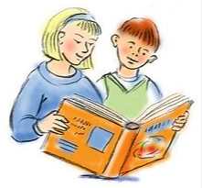  English | The Three Little Pigs  Rapunzel  Town Mouse and Country Mouse
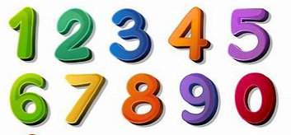  Maths | Place value, one more, one less, comparing and ordering numbers
Science | Everyday materials  Seasonal changes
History | What were household objects like in the past?
Geography | What are homes like in West Bridgford and around the world?
Art | Drawing focus  Shapes, houses, printing
Music | Menu song from Sing Up!
Computing | iAlgorithm from iCompute
RE | Belonging
PSHE | Being Me
PE | Monday PE – Fitness  Thursday PE – Ball Skills (Miss James)
Spanish | Greetings

