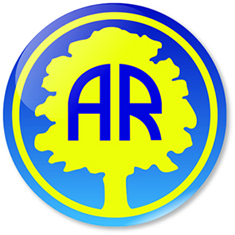
Welcome To Year 3 Letter
Year 3 Autumn 2 2023
Dear Parents and Carers,
We hope you have all had a spooktacular half-term making memories with your loved ones!
Looking back, we had a great first half term in year 3. We enjoyed learning about our skeletons, how our muscles work and how to keep our bodies healthy. Our Tree-mendous Tuesdays have started brilliantly and come rain or shine, the children have really immersed themselves into the Forest School ethos. We were blown away with the amazing information booklets the children produced, showing such a take care attitude to their work. Well done to all!
Looking ahead, we have another action-packed half-term, especially with our Creswell Crags trip and our new topic, The Stone Age. We can’t wait!
Here are some notes and reminders you may find useful:
If at any point you need to talk to the Class Teacher, please let us know and we will arrange a mutually convenient time. Alternatively use our year group email address for non-urgent notifications and information. year3@abbeyroadprimary.co.uk
PE will continue to take place on a Wednesday afternoon with Mr. Haxby from Premier Sports and on a Friday with the class teacher – hall use and weather permitting.
Swimming will take place this half term for Class 3SP (3M will be going in the Summer). Many thanks for responding to our request to help accompany the children to the pool. If you put your name down, Mrs Phillips will be in touch to let you know which of the dates you offered are needed.
This half term Year 3 will be doing many exciting learning challenges. We will be covering:
English | Writing to Entertain:  Children to write an alternative version of The Stone Age Boy  Writing to inform:  Recount of trip to Creswell Crags.  Instructional text - How to light a fire.
Maths | Addition and subtraction – column method  Multiplication and division
PE | Ball Skills, Swimming and Football
Spanish | Phonics and Pronunciation
Science | What is the dark?  Children to explore light and shadows
Art & DT | Messages: Banksy and Cave Art  Forest School: Early cave art – charcoal, mud painting, pastels  Observational drawing – positive and negative shapes  Leaf veins  Cynatope using the sun to create a picture (negative)  Artist – Anna Arkins
RE | Hindu Worship  The Story of Christmas
Music | Singing:  Mingulay boat song  Sound Symmetry
PSHE | Celebrating Differences
ICT | Exploring computer simulations, investigating options and testing predictions/ E Safety

We look forward to a fun-filled Autumn 2 and would like to thank you for your continued support.
The Year 3 Team

