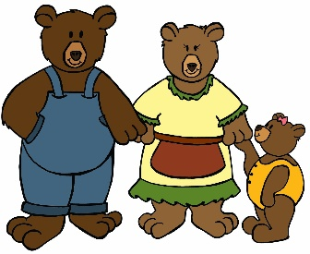
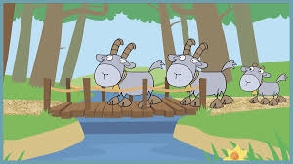

4.1.2024
Dear Parents,

Happy New Year to you all. It is lovely to see the children back in school so happy and keen to learn. Thank you so much for all of the lovely thoughtful cards, gifts and vouchers that we received at Christmas. We were overwhelmed by your kindness.

The topic for this half term is Fairy Stories, each week we will be basing our learning around a different story.
Week Beginning 4th January – The Three Billy Goats Gruff
Week Beginning 8th January – Goldilocks and the Three Bears
Week Beginning 15th January – Jack and the beanstalk and castles.
Week Beginning 22nd January – The Gingerbread man.
Week Beginning 29th January – The Little Red Hen
Week Beginning 5^{h} February – Lunar New Year

Things to Remember

- Please arrive at school on time between 8:40 and 8:50am at the latest, to enable us to begin our learning as soon as possible.
- Remember to bring your child’s reading bag to school every day. The children may be reading or having books changed on different days of the week. Please always keep reading books in their book bags. Reading is a partnership between school and home, it is important that children read for a short amount of time every evening, this can be their Ditty sheet or reading book. If you would like to swap your child’s reading book more than once a week, you can do this yourself at drop-off time. Sunshine’s’ book boxes will be inside the door. Rainbows’ book boxes will be on the picnic bench in the covered area. Please make sure you choose books with the same colour and number sticker on them (e.g. red 1 or red 2). Please then write the title of the book in their diary. Please do not change the RWI books. We will change them weekly.
- It is now a requirement that children read 4 times a week, it only needs to be for 5 minutes. A comment once a week on their progress is useful, but on the other occasions, a signature will suffice. If your child has read 4 times in a week, then they
Will have their photo on the reading chart.
Five minutes, four days - progress will be made!

- We will be doing P.E. every Friday. This term our theme is gymnastics. Please ensure that your child comes to school in suitable P.E. clothes each Friday. P.E. kits must be school uniform – white t-shirt, navy jogging bottoms / leggings / shorts, navy hoodie.
- Forest School dates:
Sunshine class Thursday 11th Jan and Thursday 18th Jan
Rainbow class Thursday 25th Jan and Thursday 1st Feb

Children will need to bring wellies and warm layers on their Forest School Day. They don’t need to wear uniform on their Forest School Day, they can wear comfortable, warm clothing such as jogging bottoms. They will need gloves, hat and a waterproof coat, waterproof trousers are also great. Their clothes will get very muddy so please don’t send any clothes that you are worried about getting dirty.

Week Beginning 5th February - All children to bring in two small boxes to make a dragon, one for the head and one for the body e.g. a cereal box and a smaller box, egg boxes are also useful.
4 small boxes or tubes, for the legs.
Please turn the boxes inside out and masking tape together so that they can be painted.
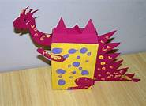
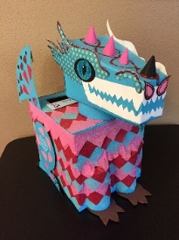
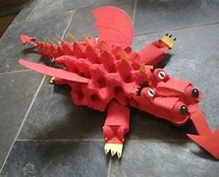

Thursday 8th February - Lunar New Year Party (Children to wear red or gold)
Half Term - Monday 12th February until Friday 16th February

Thank you all for all of your support.
Kind regards,
Reception Staff.

