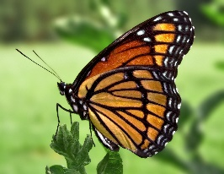
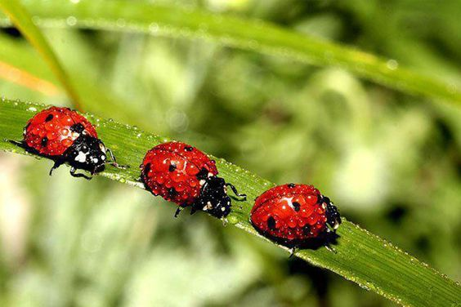
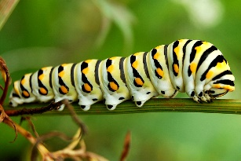
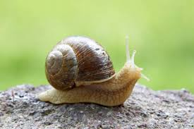
Dear

Dear Parents/carers,
Welcome back to our final term in Reception. I cannot believe how quickly that has come around. It is a long term though, so we don’t have to think about the end yet! I hope you all had a lovely Easter break and managed to get some fun times and relaxation.
During the first half term we are learning all about minibeasts.
Week 1 - Introducing minibeasts.
Week 2- Spiders
Week 3 – Snails
Week 4 – ladybirds
Week 5 – Caterpillars
Week 6 – butterflies
In Understanding the World, we will be learning about which minibeasts are insects, we will be learning about their environments, what they eat and how they move.
In Maths we will be continuing with adding on and taking away with numbers up to 10. We will be counting and looking at patterns in numbers above 10. We will also be halving, doubling and sharing as well as looking at odd and even numbers.
In Expressive Arts and Design, we will be printing, drawing from observation, copying Matisse the snail picture as well as looking at the artists Mandrian and Kandinsky.
We will be learning about symmetry through butterfly prints.
In RE we are learning about special places, we will be learning about Christian worship and what happens at church. We will be learning about the special event of a wedding.
In P.E we are learning and practising ball skills.
In Forest Schools we are cooking over the campfire as well as learning about the different seasons, trees, and minibeasts.
Sunshine class will be doing Forest Schools for the first three weeks, 18th Apil, 25th April and 2nd May.
Rainbow Class will be doing Forest Schools on the 9^{th of} May 16th May and 23rd May.
Please ensure that your child is dressed appropriately for the weather whether it is hot or cold. They need clothes and boots that they can get muddy in. Please bring clean shoes that they can wear inside.

To Help Your Child at Home

Do check your child’s reading diary every day and help him/her to: -

- Bring their diary and reading book to school every day.

- Learn sounds and worm words, please ask at the end of the day when you need new worm words.
- Once the worm words can be read, please practise writing them and ensure they are recognised in their reading books.

- Read with your child every night, 5 minutes every day makes a massive difference to their progress and confidence. As homework we expect this to happen at least four days a week.

- You can change your child’s reading books once they have read the book three times, this builds up their confidence and expression. Please always leave their books inside their book bags. The black and white paper copies of the Read Write Inc books are ones that they have read at school and need to practise. Please look after these books as we only have 20 copies of each and they are very expensive to buy as a set, even though they look cheap! We need to pass them on to a different child each week and it causes problems if they are ripped or not returned. Thank you for your support in this.

- Practise correct number and letter formation, please use the rhymes in the phonic books.

- Help your child to write a simple sentence each week,
remembering finger spaces and full stops. Let them sound out words phonetically and attempt their own spelling.

- Look around the garden or park at living and non-living things.

- Borrow story and information books on minibeasts from the library.

We are encouraging the children to drink water throughout the day. Please ensure they have a water bottle with them each day and that all clothes are labelled. We always have unnamed jumpers and cardigans left each day. As Summer approaches please ensure that your child has suncream applied at home and a sun hat as well as a raincoat!! We usually go outside whatever the weather.

Thank you so much for all of your support and for having such lovely, fabulous children for us to teach. We are looking forward to a sunny and busy half term.
Kindest regards,
The Reception Team

