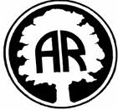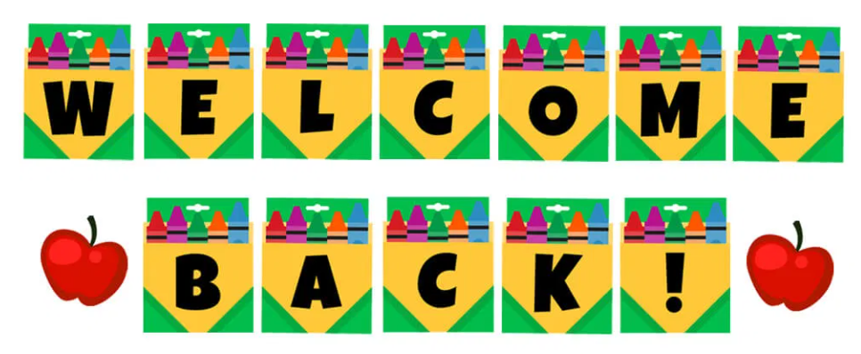

# January 2025

# Dear Parents/Carers,

Happy New Year and welcome back to Year 2! We hope you have had a wonderful Christmas break!

**Thank you!**

The Year 2 team thank you for your kind Christmas wishes and gifts – as always it is never expected but much appreciated. We had a great time celebrating Christmas with the children in school. We were most impressed with their Christmas cards with moving parts – we hope you enjoyed receiving them!

**Our learning:**

We had a great Autumn 2 half term, and the children loved our history topic, ***how did these Wonder Women change the world?*** learning about significant women who have changed history. We had an amazing ‘Lasting Legacy’ day where the children amazed us with their knowledge and enjoyed sharing information about their chosen inspirational hero.

Our Spring 1 topic, ***Animals including Humans***, promises to be just as fun and we are looking forward to exploring it with our Year 2 scientists! Other highlights of this half term include writing a story about a magical potion linked to *George’s Marvellous Medicine*, designing a healthy wrap and drawing fruit in the style of Paul Cezanne.

For more insight into what we will be covering in all our subjects this half term, please refer to the curriculum coverage letter.

Following is some additional information about Year 2 that – although some of it is repeated - you may find useful.

**Drop off and collection of pupils:**

**The timings are to remain the same.** Just a reminder:

Drop off: 8.40-8.50am

Please note: It is important that your child is in school by 8:50 so that we can begin our learning on time.

Collection: 3.30pm

**Fruit:**

Just to remind you that fruit is available at school. If you wish to provide an alternative snack, we ask that it is a healthy option and does not contain nuts.

**PE:**

We will continue to teach PE twice during the week, on Tuesdays and Wednesdays. Please can you make sure your children come dressed for PE on both days. On these winter days, they will need to wear dark jogging bottoms or leggings, a white t-shirt, a dark jumper/hoodie and trainers. (No logos please!)

**Reading:**

Please can we remind you to sign the reading diary when you have heard your child read and ask your child lots of questions about their book to help their understanding. Helpful question ideas can be found in your child’s reading diary. Children receive daily whole class Guided Reading sessions in which they develop their comprehension skills and we promote a love of reading. It is important that children continue to practise their individual reading alongside an adult at home to support their development.

Reading diaries are checked every Friday and if your child has read four times a week, they receive a point towards our whole class reward. It was wonderful to reach 100 last half term and celebrate with a cosy afternoon with our teddies, enjoying books together. Let’s get to the next 100 so we can enjoy another reading reward!

The children are encouraged to change their books regularly throughout the week and are learning to be more independent when doing this.

**Ed-shed and One Minute Maths**

Please continue to use Ed-Shed to practise the spellings the children have been taught in class and the One Minute Maths app to improve fluency and speed maths.

We look forward to another fun half term with the children!

Kind regards,

The Year 2 Team