September 2026

Dear Parents/Carers,
We are delighted with how well the children have settled into Year 1 and hope they have had a happy and positive first few days. We would like to invite you to our Year 1 Information Meeting at 4.30pm on Wednesday 16th September in Holly Classroom. The meeting will last approximately 30 minutes and will give you an opportunity to find out a little more about reading, routines and expectations in Year 1, as well as how you can support your child at home.
The meeting is aimed primarily at parents and carers, so the content is not particularly child-focused and children may find it less interesting! If possible, we would therefore encourage you to make alternative arrangements for your child. We appreciate that this isn't always possible, so if you do need to bring your child, they can sit with you during the meeting. As space in the classroom is limited, we ask that buggies are left safely under the Year 1 outdoor shelter.
If you are unable to attend, don't worry — we will send a copy of the presentation home afterwards so that you don't miss the information. We look forward to seeing you.
Your child has come home with their reading diary and two ‘colour banded books’. These are for them to read to you and can be changed once read at home. Please write the name of the book and sign in the diary once you’ve heard them read it. In Year 1 the book bags are primarily for books/diaries so spare clothes are better in carrier bags and kept on pegs.
PE days
We have PE on Monday and Wednesday. Please wear PE kits to school on these days.
- White t shirt or navy ‘Abbey Road’ t shirt
- Navy/black shorts or navy/black joggers/leggings
- Trainers / plimsolls
- Plain navy/black sweatshirt or hoodie
- No earrings

Other information
- Please send a named water bottle every day
- Please name all items of clothing
- School fruit is delivered every day so unless your child doesn’t eat the school fruit there is no need for snacks to be brought in (Please ensure all snacks are healthy eg chopped grapes, raisins, dried mango)
- Reading diaries should be in book bags every day please
- Milk should be ordered online (usually takes 2 weeks to be on the system)
- Our email address is year1@abbeyroadprimary.co.uk this is not checked during the school day so urgent messages need to go to the office
Our topic for this half term is Homes. The information on the following page shows what we shall be covering in each subject.
Further information can be found on our school website:
www.abbeyroadprimary.co.uk/curriculum-assessment/
Thank you for your support,
Year 1 Team
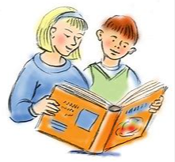  English | Jack and the Beanstalk, The Three Little Pigs, The Elves and the Shoemaker, The Town Mouse and the Country Mouse, Rumpelstiltskin, Rapunzel, The Clock Tower.
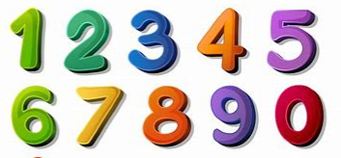  Maths | Place value, one more, one less, comparing and ordering numbers
  Science | Everyday materials  Seasonal changes
  History | What were household objects like in the past?
  Geography | What are homes like in West Bridgford and around the world?
  Art | Drawing focus  Shapes, houses, printing
  Music | Menu song from Sing Up!
  Computing | iAlgorithm from iCompute
  RE | Belonging
  PSHE | Being Me
  PE | Monday PE – Fitness  Wednesday PE – Ball Skills

